CellMo Adaptation SW Telephony Services Technology Team
SIM ATK TSY
Design Document

SIM ATK TSY | Ext-Lasse Kunnasluoto

Change history:

Version | Date | Status | Comments
0.1 | 23.Aug.04 | Draft | Initial draft
0.2 | 26.Aug.04 | Draft | Document commented
0.3 | 26.Aug | Draft | Comments considered
0.4 | 02.Sep.04 | Draft | Updating continues
0.5 | 03.Sep.04 | Proposal
0.6 | 06.Oct.04 | Proposal | Changes made based on comments.
0.7 | 11.Oct.04 | Proposal | Changes made based on comments
1.0 | 11.Oct.04 | Approved | Mikko Saarela
1.1 | 08.Jun.05 | Proposal | General update from S60 2.6 to S60 3.0.  Updated e.g. class diagrams, start-up sequence, API definition, MO SMS control, refresh, Call contol, SIM Session End features and Chapter 8.
Table of contents:

1. Document control 6
1.1 References 6
1.2 Documentation conventions 6
1.3 Abbreviations 7
1.4 Definitions 7
2. General 8
2.1 Introduction 8
2.2 Sub system environment 8
2.3 Services required 9
2.3.1 From Symbian OS subsystems 9
2.3.2 From Domestic OS subsystems 10
2.3.3 From HW 10
2.4 Services provided 10
2.4.1 UI 10
2.4.2 SW IF 10
3. Design 11
3.1 SIM ATK TSY class diagram 11
3.2 Class Descriptions 11
3.2.1 API definitions 17
3.2.1.1 <SatMessaging.h> CtsySatMessaging 17
3.2.2 Structs, Type Definitions and Enumerations 17
3.2.3 Flag definitions 17
3.2.4 State diagrams 17
3.3 Operations 17
3.3.1 General sequences 17
3.3.1.1 Generic Start up – Checking buffer for commands received before SIM ATK TSY boot up 17
3.3.1.2 SAT Command Notify – Notification Request of Received SAT Command 19
3.3.1.3 SAT Command Notify Cancel – Cancel the Notification Request 20
3.3.1.4 SAT Message Received – Receiving SAT Command from ISC API 21
3.3.1.5 SAT Command Terminal Response – Response to Received SAT Command 22
3.3.1.6 Unable to Process SAT Command – Received Message Request Not Pending 23
3.3.1.7 Command Beyond Me Capabilities - Not supported command reveiced 24
3.3.1.8 Sat Menu Selection – Item Selection from SAT Main Menu 25
3.3.1.9 Command Not Supported – SIM ATK TSY Does Not Support Requested Command 26
3.3.1.10 SIM Session End – SIM Application Toolkit Session End 27
3.3.1.11 SAT SMS Sending – Send SAT SMS No Logging 29
3.3.2 Call Control 30
3.3.2.1 Startup 30
3.3.2.1.1 Activation of guardians and retrieval of location data. 30
3.3.2.2 Call 33
3.3.2.2.1 Allowed Call 33
3.3.2.2.2 Modified Call 39
3.3.2.2.3 Rejected call 42
3.3.2.3 SS 43
3.3.2.3.1 Allowed SS 43
3.3.2.3.2 Modified SS 45
3.3.2.3.3 Rejected SS 51
3.3.2.4 USSD 51
3.3.2.4.1 Allowed USSD 51
3.3.2.4.2 Modified USSD 51
3.3.2.4.3 Rejected USSD 52
3.3.3 Data Download to SIM 52
3.3.3.1 Startup 52
3.3.3.1.1 Activation of CB Data Download and retrieval of the list containing the allowed msg id:s. 52
3.3.3.1.2 Activation of SMS-PP Data Download messages 53
3.3.3.2 Cell Broadcast Data Download reception 54
3.3.3.3 SMS-PP Data Download reception 55
3.3.4 Refresh 56
3.3.5 MO Short Message Control by UICC 58
3.3.5.1 Start Up 58
3.3.5.1.1 Activation of MO SMS control 58
3.3.5.2 Basic User originated SMS 59
3.3.5.3 Basic proactive originated SMS request 61
3.3.5.4 Modified SMS 62
3.3.5.5 Rejected SMS 62
4. System Resource Usage 63
4.1 Files 63
4.2 Databases 63
4.3 Memory consumption 63
4.4 Task allocation 63
4.5 Performance 63
4.6 Timers 63
5. Exception handling 64
6. Limitations 65
7. Interfaces to Common TSY and Nokia TSY 66
7.1 Start-up and closing 66
7.2 Message receiving and sending 66
7.3 SMS sending 66
7.4 Status of MO SMS Control activation 66
8. SIM ATK TSY functionality versus (U)SAT API 67
8.1 Supported features that behave as specified in (U)SAT API 67
8.2 Supported features that behave differently than specified in (U)SAT API 67
8.2.1 Call Control 67
8.2.2 Send SS 67
8.2.3 Provide local info 68
8.2.4 MO Short Message control by UICC 68
8.2.5 Event download 68
8.3 Supported features that are not visible to (U)SAT API 68
8.3.1 Terminal profile 68
8.3.2 Cell Broadcast Data download 68
8.3.3 SMS-PP Data download 68
8.3.4 Timer management 69
8.3.5 More time 69
8.3.6 Event Download 69
8.3.7 Polling Off 69
8.3.8 Poll Interval 69
8.4 Not supported features by SIM ATK TSY but defined by (U)SAT API. 69
8.5 Other deviations 70

Document control

References
- ETSI GSM Specification 11.14 | http://www.etsi.org/
- (U)SAT API specification | http://www.symbian.com/
- Application Toolkit Server Message Specification | http://oucmswww.nmp.nokia.com:58080/document_browser/ccm_wa/GIF_SPECS/
- ISI Network Select Server Message Descriptions | http://oucmswww.nmp.nokia.com:58080/document_browser/ccm_wa/GIF_SPECS/
- Info Server Message Descriptions | http://oucmswww.nmp.nokia.com:58080/document_browser/ccm_wa/GIF_SPECS/
- ISI GSS Server Message Descriptions | http://oucmswww.nmp.nokia.com:58080/document_browser/ccm_wa/GIF_SPECS/
- ISI SMS Server Message Descriptions | http://oucmswww.nmp.nokia.com:58080/document_browser/ccm_wa/GIF_SPECS/
- ISI SIM Server Description | http://oucmswww.nmp.nokia.com:58080/document_browser/ccm_wa/GIF_SPECS/
- Series 60 Platform 2.6 Common Tsy Design document
- Series 60 Platform 2.6 Nokia Tsy Design document
- Series 60 Platform 2.6 Satserver Design document

Documentation conventions
Code is shown with Courier New font.

Abbreviations
DOS | Domestic OS
BER-TLV | Basic Encoding Rules, Tag Length Value
EFcbmid | Cell broadcast message identifier for data download elementary file
EPOC | Old term for Symbian OS
ESN | Electronical serial number. Used in CDMA.
ETel | EPOC Telephony Server
MTC | Mobile terminal controller
SAT | Sim Application Toolkit
TSY | Symbian OS Telephony Subsystem
TLV | Tag length, value
UI | User Interface
USSD | Unstructured supplementary service data

Definitions
Multimode ETel Custom API | SERIES 60 specific extension to ETel APIs

General
This document describes the design of the SIM ATK TSY module.

Introduction
SIM ATK TSY is the provider module for the (U)SAT API defined by Symbian and it implements the interface between Domestic OS and (U)SAT API. Tasks of the SIM ATK TSY include e.g. saving information about current status of Domestic OS and saving information about the notifications that clients want to receive.

Sub system environment

The SIM ATK TSY and ETel server run in the same thread, which belongs to the communications process of the Symbian OS. Figure below presents the logical context of SIM ATK TSY. SIM ATK TSY module implements the abstract TSY interface specified by Symbian, which the ETel Server uses to serve the ETel API requests, made. The SAT server is considered as the main user of (U)SAT API. More than one entities monitoring the (U)SAT API does not matter to SIM ATK TSY But communicating to SIM ATK TSY has to implemented so that it looks like single client to SIM ATK TSY. In other words if there is more than one client they have to have some sort of common agreement about how to communicate with the SIM ATK TSY. File logging interface is used for test logging purposes. SIM ATK TSY uses Nokia TSY’s connection to the Domestic OS to communicate with it. For sub system details, see chapter 1.1 , references [4], [5], [6], [7] and [8].
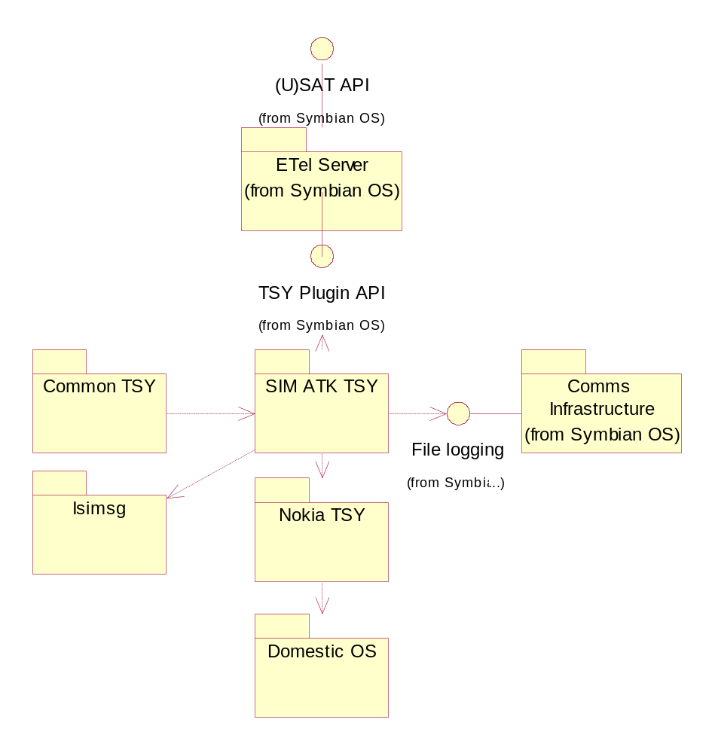
Figure2.1 SIM ATK TSY environment
Above figure gives the overview of SIM ATK TSY component. It gives a basic idea what entities there are, and main routes of the function calls. For further information about (U)SAT API see (U)SAT API specification.

Services required

From Symbian OS subsystems
SIM ATK TSY requires services directly from following Symbian OS subsystems:
  - ETel server
  - File Logging interface
  - Common TSY
  - Nokia TSY
  - Isimsg

From Domestic OS subsystems
SIM ATK TSY requires services directly from following Domestic OS subsystems. For sub system specific information about (U)SAT API see (U)SAT API specification
  - SIMSON
  - Network selection server
  - Call guardian
  - Supplementary Services/USSD guardian
  - Info server
  - GSM stack server
  - Short message server

From HW
This component has no direct HW interfaces.

Services provided

UI
SIM ATK TSY does not provide user interface.

SW IF
(U)SAT API provided by Symbian Ltd, ISI ATK interface for ATK related messaging to Domestic OS servers.

Design

SIM ATK TSY class diagram

Each SAT proactive command has its own class, which holds the information relevant to the command in question. Proactive command is the command issued by (U)SIM card within the T=0 protocol in order to for example display text or set up call. See ETSI GSM Specification 11.14 for further details. All proactive command classes are created when CtsySatMessaging object is created. This way each proactive command is handled by its own notify class. The proactive commands are encapsulated to individual classes in order to simplify the design and updating.
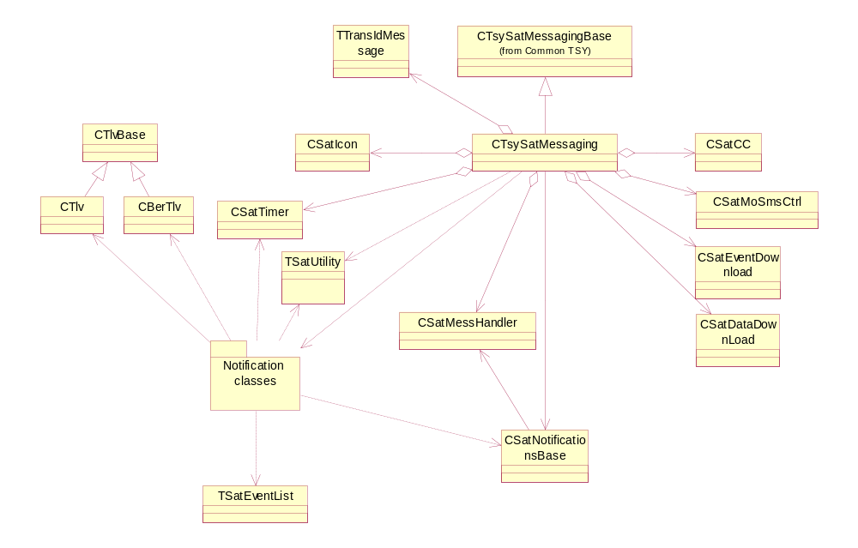
Figure 3.1SIM ATK TSY model

Class Descriptions
Class | Description | Header file
CBerTlv | CBerTlv contains methods to read BER-TLV data. | Ber_tlv.h
CSatCC | Sat Call control handling | SatCC.h
CSatDataDownload | Cell broadcast data download and SMS PP data download handling | SatDataDownLoad.h
CSatEventDownload | Sat event download handling | SatEventDownLoad.h
CSatIcon | Icon data handling | SatIcon.h
CSatMoSmsCtrl | Sat MO SMS control handling | SatMoSmsCtrl.h
CSatMessHandler | Sat message handler class. Handles message sending and receiving to and from ISCAPI. | SatMessHandler.h
CSatNotificationsBase | Sat notifications base class. Base class for SAT command notification classes. | SatNotifications.h
CSatNotifyCallControlRequest | Sat Call Control notification class. Called when client requests to be notified if a request (of any other existing client) has been modified by call control. | SatNotifications.h
CSatNotifyDisplayText | Sat Display Text notification class. Called when client requests to be notified when Display Text command arrives from SIM. This command instructs the SAT to display a text message in the UI. It allows SIM to define the priority of that message, and the text string format. | SatNotifications.h
CSatNotifyGetInkey | Sat Get Inkey notification class. Called when client requests to be notified when Get Inkey command arrives from SIM. This command instructs the user to enter a single character in the UI. Any response entered by the user shall be passed transparently by the SAT to the SIM. | SatNotifications.h
CSatNotifyGetInput | Sat Get Input notification class. Called when client requests to be notified when Get Input command arrives from SIM. This command instructs the user to enter character string in the UI. Any response string entered by the user shall be passed by the SAT to the SIM. If the SIM provides a default text, the SAT shall display this default text, which user may accept, reject or edit as the response string. | SatNotifications.h
CSatNotifyLanguageNotification | Sat Language Notification information notification class. Called when client requests to be notified when Language Notification command arrives from the SIM: This command orders the phone to give its currently used language. Success of this request and possible language shall be passed by SAT to SIM. | SatNotifications.h
CSatNotifyLaunchBrowser | Sat Notify launch browser notification class. Called when client requests to be notified when Launch Browser command arrives from the SIM: This command orders the phone to open browser. Success of this request shall be passed by SAT to the SIM. | SatNotifications.h
CSatNotifyLocalInfo | Sat local information notification class. Called when client requests to be notified when Provide Local Info command arrives from the SIM: Success of this request and possible local information shall be passed by SAT to SIM. | SatNotifications.h
CSatNotifyMoreTime | Sat More Time information notification class. Handles the More Time command received from SIM. Responds ok to time requests | SatNotifications.h
CSatNotifyPlayTone | Sat Play Tone notification class. Called when client requests to be notified when Play Tone command arrives from SIM. Commands the phone to play certain tone. Success of this request shall be passed by SAT to SIM. | SatNotifications.h
CSatNotifyPollingOff | Sat Notify polling off notification class. Handles the Polling Off command received from SIM. Commands the phone to stop polling. Success of this request shall be passed by SAT to SIM | SatNotifications.h
CSatNotifyPollInterval | Sat Poll Interval notification class. Handles the Poll Interval command received from SIM. This procedure negotiates how often the ME shall send STATUS commands related to Proactive Polling Does not require any interaction with the Symbian OS side, and has no impact on the Etel API. | SatNotifications.h
CSNotifyRefresh | Sat Refresh notification class. Called when client requests to be notified when Refresh command arrives from SIM. The purpose of this command is to enable the SAT (which alerts other applications in the phone) to be notified of the changes to the SIM configuration that have occurred as the result of a SIM application activity. It is up to SAT to ensure this is done correctly. | SatNotifications.h
CSatNotifySelectItem | Sat Select Item notification class. Called when client requests to be notified when Select Item command arrives from SIM. The SIM shall supply a set of items from which the user may choose one. Each item comprises a short identifier (used to indicate the selection) and a text string. Optionally the SIM may include an alpha identifier. This is intended to act as a title for the list of items. | SatNotifications.h
CSatNotifySendDtmf | Sat Send Dtmf notification class. Called when client requests to be notified when Send Dtmf command arrives from SIM. Sends a Dtmf string towards the network. Upon receiving this command, the SAT shall decide if it is able to execute the command. | SatNotifications.h
CSatNotifySendSm | Sat Send SM notification class. Called when client requests to be notified when Send SM command arrives from SIM. A short message to be sent to the network. Success of this request is passed from SAT to SIM. | SatNotifications.h
CSatNotifySendSs | Sat Send SS notification class. Called when client requests to be notified when Send SS command arrives from SIM. Sends a SS string towards the network. Upon receiving this command, the SAT shall decide if it is able to execute the command. | SatNotifications.h
CSatNotifySendUssd | SAT Send USSD notification class. Called when client requests to be notified when Send USSD command arrives from SIM. Sends an USSD string towards the network. Upon receiving this command, the SAT shall decide if it is able to execute the command. | SatNotifications.h
CSatNotifySetUpCall | Sat Setup Call notification class. Called when client requests to be notified when Setup Call command arrives from SIM. Setup a call. Can be setup in three different ways:  - Set up a call, only if not currently busy on another call  - Set up a call, put all other call on hold  - Set up a call, disconnect other calls | SatNotifications.h
CSatNotifySetUpEventList | Sat Notify set up event list notification class. Called when client requests to be notified if Set Up Event List command arrives from SIM. Sets up, modifies or cancels the list of event that SIM wishes to monitor. Success of this request is passed from SAT to SIM. | SatNotifications.h
CSatNotifySetUpIdleModeText | Sat Set Up Idle Mode Text notification class. Called when client requests to be notified when Set Up Idle Mode Text is received from SIM. Command orders the UI to show some text in idle state. Success of this request is passed from SAT to SIM. | SatNotifications.h
CSatNotifySetUpMenu | Sat Setup Menu notification class. Called when client requests to be notified when Setup Menu command arrives from SIM. The SIM shall supply a set of menu items, which shall be used as a main menu in SAT application. The user has then the opportunity to choose one of these menu items at his own discretion. Each item comprises a short identifier (used to indicate the selection) and a text string. Also an Alpha identifier is supplied which acts as a title for the list of menu items. | SatNotifications.h
CSatNotifySimSessionEnd | SAT SIM Session End notification class. SIM Session end tells the satserver client when the last command in SIM application has been processed, i.e. the SIM application has ended. | SatNotifications.h
CSatNotifyTimerMgmt | Sat Notify Timer management notification class. Handles the Timer Management command received from SIM. Timer management does not require any interaction with the Symbian OS side, and has no impact on the Etel API. | SatNotifications.h
CSatNotifyOpenChannel | SAT Open Channel notification class. | SatNotifications.h
CSatNotifyGetChannelStatus | SAT Notify Get Channel Status notification class. | SatNotifications.h
CSatNotifyCloseChannel | SAT Notify Close Channel notification class. | SatNotifications.h
CSatNotifyReceiveData | SAT Notify ReceiveData notification class. | SatNotifications.h
CSatNotifySendData | SAT Notify ReceiveData notification class. | SatNotifications.h
CSatNotifyMoSmControlRequest | SAT MO-SMS Control notification class. This is used especially for returning AlphaId and ControlResult to SatServer. | SatNotifications.h
CSatTimer | Timer for timer management | SatTimer.h
CTlv | CTlv contains methods to read simple TLV data | Ber_tlv.h
CTlvBase | TLV Base class. Methods common for CTlv and CBerTlv | Ber_tlv.h
CTsySatMessaging | Each SAT proactive command has its own class, which holds the information relevant to the command in question. All proactive command classes are created when CTsySatMessaging object is created. This way each proactive command is handled by its own notify class. The proactive commands are encapsulated to individual classes in order to simplify the design and updating. This class also handles SMS message sending and menu selection SAT features. All not supported functions are completed here | SatMessaging.h
TSatEventList | Handles event list management for SIM ATK TSY, used to keep track of events that need to be sent to USIM. | SatEventDownLoad.h
TSatUtility | This class includes small utility functions for SIM ATK TSY specific use. | SatUtil.h
TTlv | Type for Tag Length Value buffer default tlv with size of 255 | Ber_tlv.h
TTlvBase | Generic BER-TLV constructor class, can be used to create TLVs | Ber_tlv.h
TTlvBuf | Type for Tag Length Value buffer. Define tlv that is smaller than default max size of 255 | Ber_tlv.h

API definitions

<SatMessaging.h> CtsySatMessaging
CtsySatMessaging | Description
~CTsySatMessaging | Destructor
NewL | Used for creating an object of type CtsySatMessaging (Note: Only one object of this type should exist in the TSY).
IsMoSmControlBySimActivated | This methods returns ETrue if MO SMS Control is activated. Otherwise, it returns EFalse
CompleteSendSmsMessage | Message from Common TSY side that message sending has been completed

Structs, Type Definitions and Enumerations
There are no struct, type or enumeration definitions that would be visible outside SIM ATK TSY.

Flag definitions
There are no flag definitions in SIM ATK TSY.

State diagrams
See mdl presentation of the (U) SAT API delivered among Symbian OS releases. See chapter 3.3 Operations.

Operations

General sequences

Generic Start up – Checking buffer for commands received before SIM ATK TSY boot up
This sequence illustrates the start up of the phone in very general level from sim application toolkit point of view. It describes the functionality between (U)SAT API and (U)ICC card. Methods related to this sequence are marked to be type SAT01 in the source code.
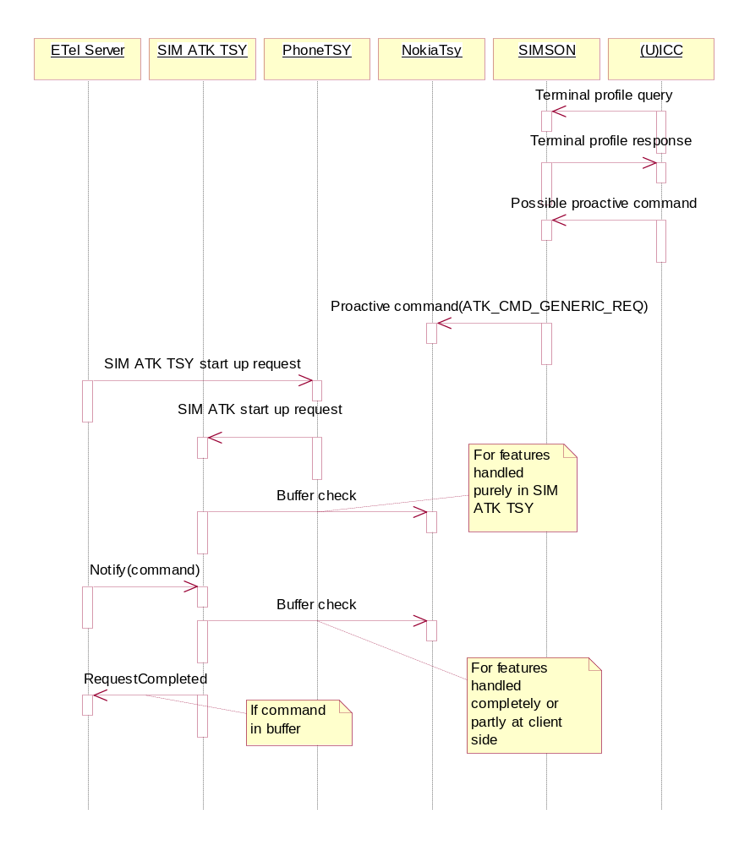
Figure 3.2 Simplified model of start up.
Operation | Generic Start up
Preconditions | SIM ATK TSY is not running.
Description | SIM ATK TSY starts up and checks the buffer for possibility that SIMSON has already sent proactive commands to APE.
Inputs | SIM ATK TSY starting request
Modifies | The state of SIM ATK TSY
Outputs | None or handling of proactive command
Postconditions | SIM ATK TSY is running.
Related To | All SIM ATK TSY classes
Related Event | SIM ATK TSY start up
Exceptions | Boot up fails

SAT Command Notify – Notification Request of Received SAT Command

This sequence illustrates the notification request for SAT commands. SAT ETel API requests SAT command notification via ETel Server. TSY Messaging calls corresponding notify class method, which sets the request pending by setting the request handle. Methods related to this sequence are marked to be type SAT02 in the source code.

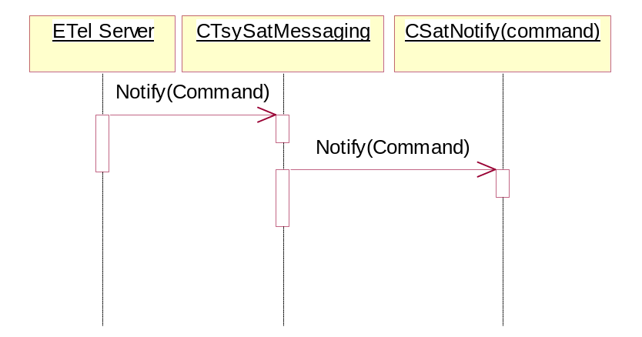
Figure 3.3 Sat Command Notify
Operation | Sat command notify
Preconditions | SIM ATK TSY must be running.
Description | Client sends notification request about possible incoming proactive command
Inputs | Notification request
Modifies | State of notification handling class
Outputs | None
Postconditions | SIM ATK TSY notifies about incoming proactive command.
Related To | To the class that handles the requested notification.
Related Event | Sat command notification request
Exceptions | None

SAT Command Notify Cancel – Cancel the Notification Request

This sequence illustrates how to cancel the pending notification request of SAT commands. SAT ETel API send notification cancel request via ETel Server to TSY messaging class. It calls corresponding SAT notify class cancel method. SAT notify class completes request to ETel Server. Methods related to this sequence are marked to be type SAT03 in the source code.

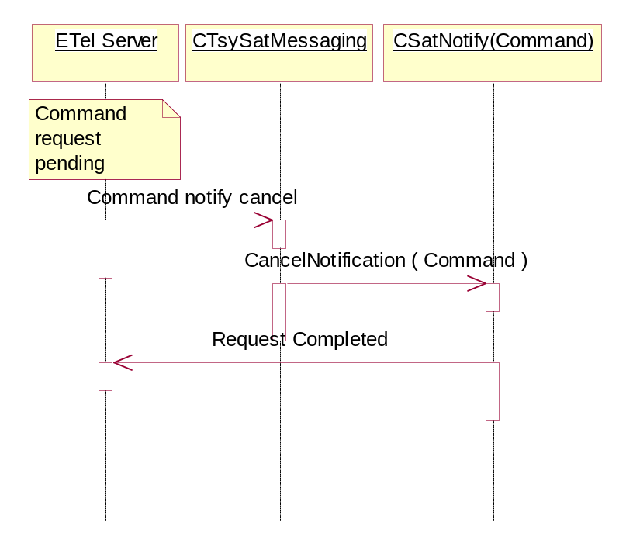
Figure 3.4 Sat command notify cancel
Operation | Sat command notification cancellation
Preconditions | SIM ATK TSY must be running. Notification to be cancelled must be previously successfully requested and it is not completed
Description | Client cancels the notification request
Inputs | Notification cancellation request
Modifies | State of notification handling class
Outputs | Client will no longer be notified about incoming proactive command. Possible notification related proactive command is completed with error to Domestic OS.
Postconditions | SIM ATK TSY is running.
Related To | To the class that handles the specific notification.
Related Event | Sat Command noticication cancellation
Exceptions | None

SAT Message Received – Receiving SAT Command from ISC API

This sequence illustrates how SIM ATK TSY receives SAT commands from ISC API. ISC API call SAT message handler function SAT message received. It forwards message to the corresponding SAT notify class method. Method processes the command and completes request to ETel Server. Methods related to this sequence are marked to be type SAT04 in the source code.

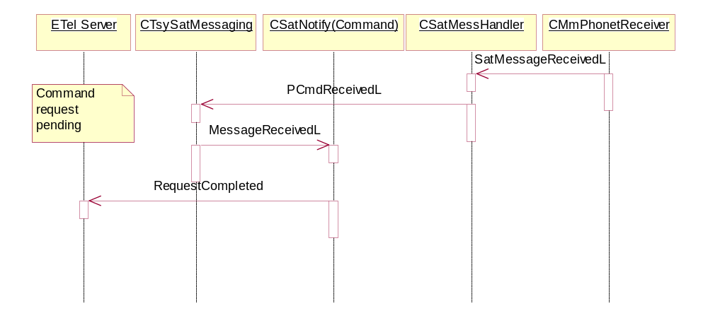
Figure 3.5 Receiving sat command
Operation | Sat Message Received
Preconditions | SIM ATK TSY is running. Appropriate notification request has been made to SIM ATK TSY.
Description | Proactive command is received from Domestic OS
Inputs | Proactive command
Modifies | State of a specific notification handling class
Outputs | Notification completion
Postconditions | SIM ATK TSY is running.
Related To | To the class that handles the specific notification.
Related Event | Notification completion
Exceptions | Message receiving fails

SAT Command Terminal Response – Response to Received SAT Command

This sequence illustrates how SIM ATK TSY responds to receive SAT command from ISC API. Prior this proactive command has received from ISC API. (U)SAT ETel API sends terminal response to TSY SAT messaging class via ETel Server. It calls corresponding SAT notify class, which process the data, and calls corresponding ISI message sending function from SAT message handler class. It sends the response to ISC API.

TSY SAT messaging class completes the request to Etel Server. Methods related to this sequence are marked to be type SAT05 in the source code.
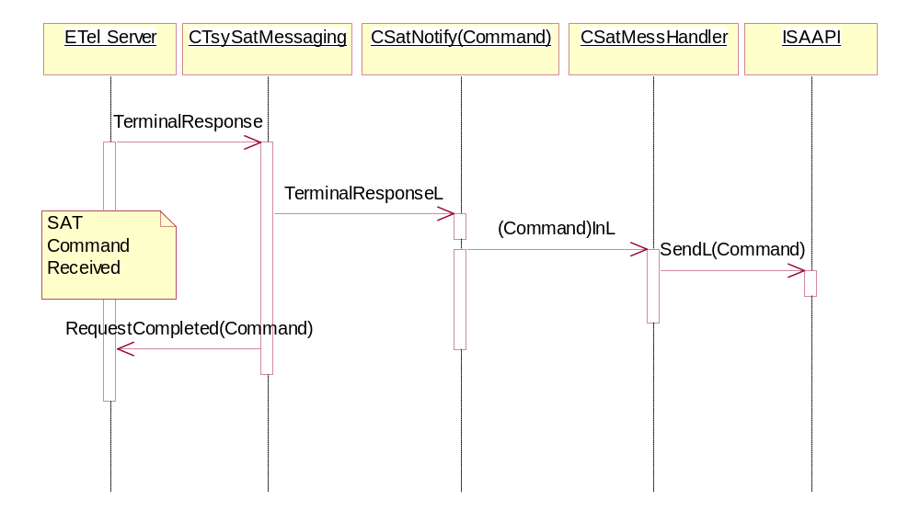
Figure 3.6 Sat command terminal response
Operation | Terminal response Received
Preconditions | SIM ATK TSY is running. Notification has been completed.
Description | Terminal response is received from client
Inputs | Terminal response
Modifies | State of a specific notification handling class
Outputs | Terminal response sending to Domestic OS. Completion of terminal response request to client
Postconditions | SIM ATK TSY is running.
Related To | To the class that handles the specific notification
Related Event | Terminal response
Exceptions | Message sending fails

Unable to Process SAT Command – Received Message Request Not Pending

This sequence illustrates how SIM ATK TSY responds to receive SAT command from ISC API if Command Request is not pending.

SAT message handler receives SAT message from ISC API. It forwards it to SAT TSY messaging class function Proactive Command (Paced) Received. SAT TSY messaging class calls related SAT notify class corresponding method. Because request is not pending for received message, corresponding SAT message handler function is called, with status KMeUnableToProcessCmd. SAT message handler sends message to ISC API.

Methods related to this sequence are marked to be type SAT06 in the source code.
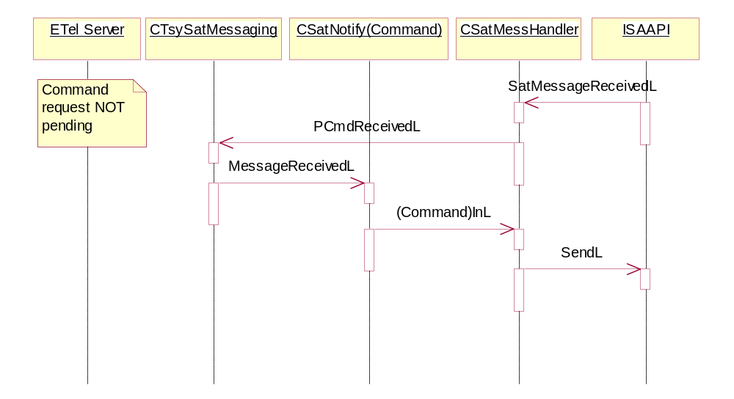
Figure 3.7 Sat unable to process sat command
Operation | Unable to process command
Preconditions | SIM ATK TSY is running. Client has not sent the notification request
Description | Proactive command is received from Domestic OS
Inputs | Proactive command
Modifies | State of a specific notification handling class
Outputs | Terminal response sending to Domestic OS.
Postconditions | SIM ATK TSY is running.
Related To | To the class that handles the specific notification
Related Event | Proactive command received and client is not ready to handle them
Exceptions | Message sending fails, message receiving fails

Command Beyond Me Capabilities - Not supported command reveiced
This sequence illustrates how SIM ATK TSY responses to an unsupported SAT command received from the ISC API. When this kind of command is received, terminal response is sent immediately back to UICC with the result Command Beyond Me Capabilities.
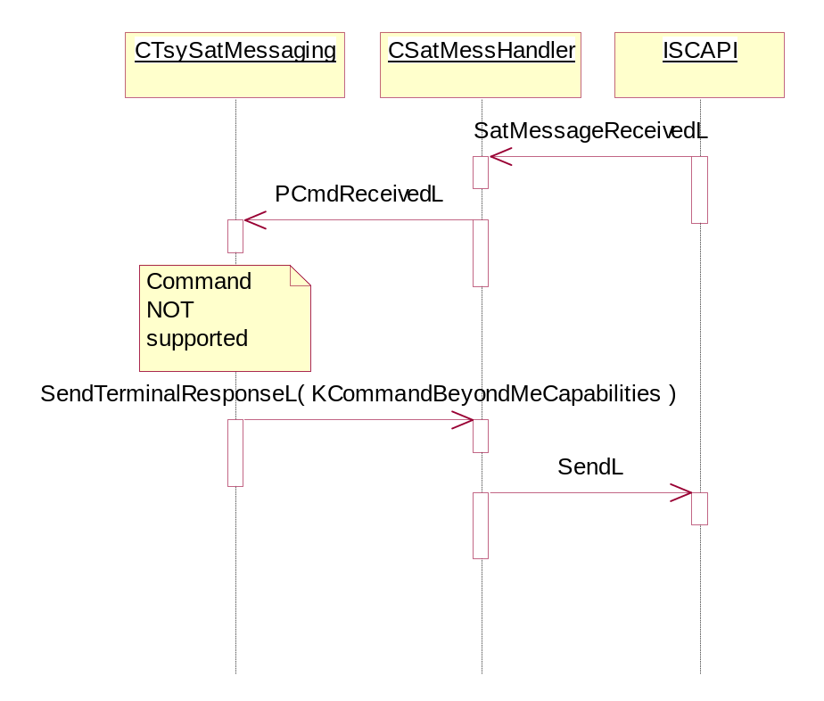
Figure 3..8 Command beyond Me Capabilities

Sat Menu Selection – Item Selection from SAT Main Menu

This sequence illustrates how item is selected from SAT main menu. SAT main menu is the menu which is received via SetUp Menu SAT command when mobile device is switched 'On'.

SAT ETel API sends Menu selection request via ETel Server to corresponding TSY SAT messaging class method. It constructs the message and sends it to corresponding SAT message handler function, which sends it to ISC API.

SAT TSY messaging class completes request to ETel Server.

Methods related to this sequence are marked to be type SAT07 in the source code.
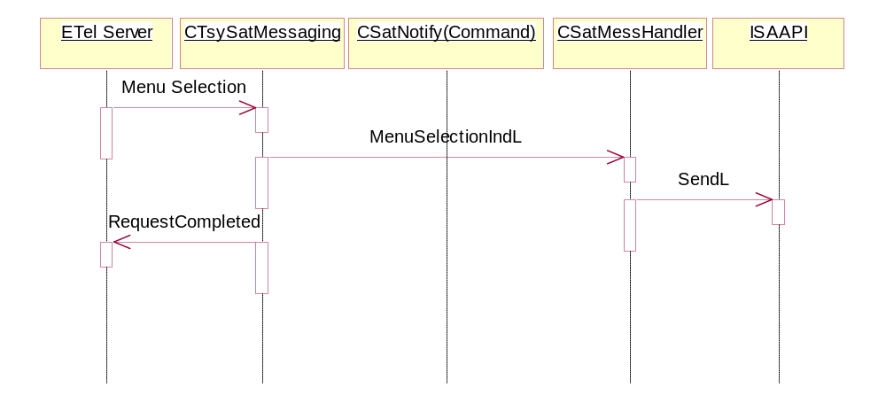
Figure 3.9 sat menu selection
Operation | Sat Menu Selection
Preconditions | SIM ATK TSY is running.
Description | Menu item selected
Inputs | Menu selection
Modifies | None
Outputs | Menu selection is sent to Domestic OS. Menu selection request is completed
Postconditions | SIM ATK TSY is running.
Related To | CTsySatMessaging, CTsySatMessHandler
Related Event | Menu selection
Exceptions | Message sending fails

Command Not Supported – SIM ATK TSY Does Not Support Requested Command

This sequence illustrates what happens if SIM ATK TSY does not support the requested SAT command, or request is served at once.

SAT ETel API request SAT command from TSY SAT messaging via ETel Server. Because the request is not supported, SAT TSY messaging completes the request to ETel Server with KErrNotSupported.

Same functionality occurs when SAT ETel API tries to cancel the command, which is served at once, i.e. SIM ATK TSY sends a message to ISC API right away. These commands are, for example, menu selection indication and SAT SMS sending. Requests cannot be cancelled because they are handled so quickly in domestic OS and there is no cancellation possibility in domestic OS interface.

Methods related to this sequence are marked to be type SAT08 in the source code.
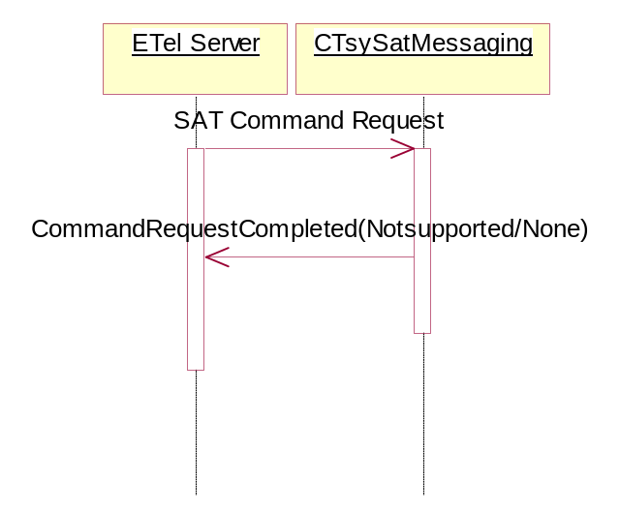
Figure 3.10 Sat command not supported
Operation | Sat Command Not Supported
Preconditions | SIM ATK TSY is running.
Description | Request for unsupported feature of feature that completely handled in SIM ATK TSY.
Inputs | Unsupported request
Modifies | None
Outputs | Completion of unsupported request
Postconditions | SIM ATK TSY is running.
Related To | CTsySatMessaging, CTsySatMessHandler
Related Event | Unsupported request
Exceptions | None

SIM Session End – SIM Application Toolkit Session End

This sequence illustrates SIM session ending sequence. When SAT message handler receives an ATK_SW_DATA_NTF from ISC API, it will check is this for previously sent terminal response command by comparing transaction ID values. If transaction ID matches with the previously sent terminal response, SAT message handler forwards the message to SAT TSY messaging class function SessionEndL. It calls SAT notify SIM session end method message received which completes request to the ETel Server.

If request was not pending, SAT notify SIM session end method simply returns.

Methods related to this sequence are marked to be type SAT09 in the source code.
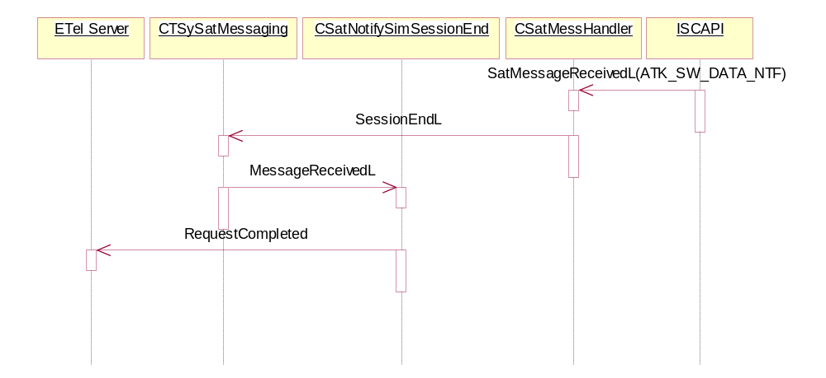
Figure 3.11: Sim session end
Operation | Sim Session end
Preconditions | SIM ATK TSY is running. Terminal response has been sent to Domestic OS
Description | Notifying client about ended session
Inputs | Verification message for terminal response received from Domestic OS
Modifies | None
Outputs | Completion of session end notification
Postconditions | SIM ATK TSY is running.
Related To | CTsySatMessaging, CTsySatMessHandler, CSatNotifySimSessionEnd
Related Event | SIM session completion
Exceptions | Message receiving fails, no verification, verification fails

SAT SMS Sending – Send SAT SMS No Logging

This sequence illustrates SAT SMS message sending sequence.

Prior this Send SM SAT command has been received from ISC API. (U)SAT ETel API sends SAT SMS sending request to TSY SAT messaging class via ETel Server. TSY SAT messaging class calls MMSMS module SAT SMS sending function called CMmSmsTsy::SendSatMessage. MMSMS sends message to ISC API, and waits SMS message send response.

When response is received, MMSMS calls TSY SAT Messaging class SAT SMS sending complete function. This function logs the message sending status, and completes request to the ETel Server.

It could be possible to change the functionality so in future that messages would be sent SIM ATK TSY. In order to accomplish that some sort miniature sms tsy would have to be implemented under SIM ATK TSY.

Need for SMS sending through SIM ATK TSY disappears when 2.0 or newer version of (U)SAT API will be taken in use.

Methods related to this sequence are marked to be type SAT10 in the source code.
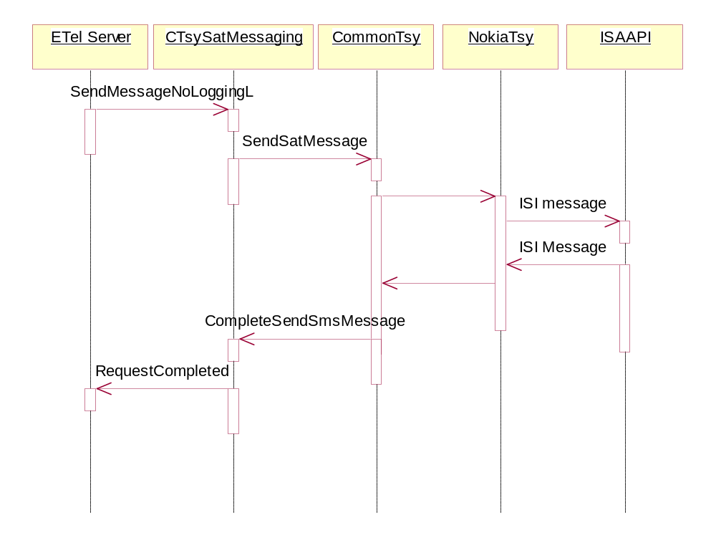
Figure 3.12 Sat SMS sending
Operation | Sat SMS sending
Preconditions | SIM ATK TSY is running. Proactive send sms notification completed to client.
Description | Sending of proactive originated sms sending request
Inputs | SMS sending request
Modifies | State of sms sending classes
Outputs | SMS sending request made to Domestic OS. Sms sending request completed to client
Postconditions | SIM ATK TSY is running.
Related To | CTsySatMessaging, CTsySatMessHandler,
Related Event | SMS sending
Exceptions | Message sending fails

Call Control

Startup

Activation of guardians and retrieval of location data.

At start up SIM ATK TSY has to check if call control is supported in SIM card attached to mobile phone. It checks this information by checking SIM service table of the card. SIM ATK TSY needs as well the location data because location information is mandatory information to be given to SIM in case of call control event.
SIM ATK TSY
SIMSON
NET server
CALL server
SS server
TSY start up proceeds
so far that location info
is queried by
satmessaging class
NET_REG_STATUS_GET_REQ
TSY start up proceeds so
far that call control and
USSD data object support
is checked from SIM
SIM_READ_TABLE_REQ(USSD_IN_CALL_CONTROL_AVAIL)
CALL_GSM_CCP_GET_REQ
TSY start up proceeds so
far that default bearer for (
voice ) call is queried from
CALL server
SIM_READ_TABLE_RESP
NET_REG_STATUS_GET_RESP
CALL_GSM_CCP_GET_RESP
ATK_STATUS_IND
ATK_STATUS_IND
Based on results retrieved
from SIMSON, guardians are
either activated or
deactivated
SIM_READ_TABLE_REQ(CALL_CONTROL_AVAIL)
SIM_READ_TABLE_RESP

Figure 3.13: Start up from Call Control point of view
Operation | Start up from call control point of view
Preconditions | SIM ATK TSY is not running.
Description | Start up from call control point of view.
Inputs | SIM ATK TSY starting request
Modifies | Gathers required information for call control, activates/deactivates guardians
Outputs | SIM service table reading request, guardian activation indication, network status query.
Postconditions | SIM ATK TSY is running and ready to handle call control events
Related To | CSatCC, CTsySatMessHandler, CTsySatMessaging
Related Event | Start up
Exceptions | Message receiving fails, message sending fails, start up fails

Call

Allowed Call

Basic user originated call
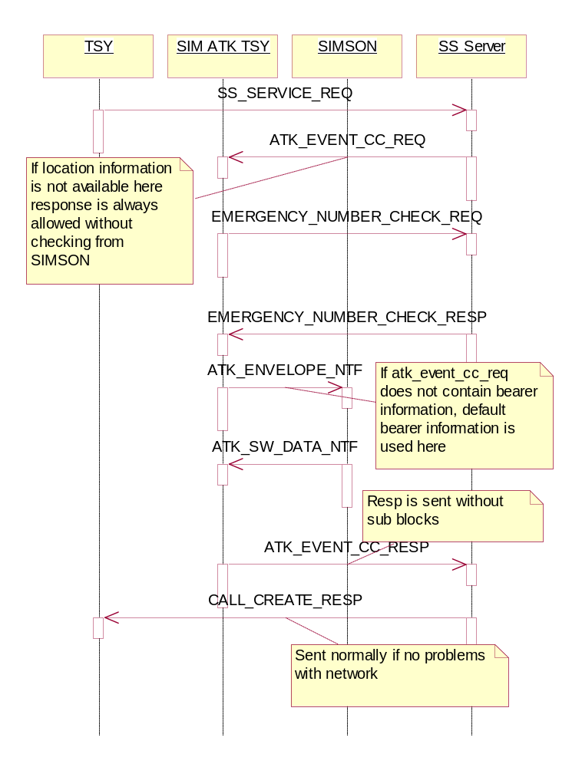
Figure 3.14: Basic user originated call from call control point of view
Operation | Basic user originated call from call control point of view.
Preconditions | SIM ATK TSY is running.
Description | Basic user originated call from call control point of view.
Inputs | Call control event request from Guardian, envelope from SIMSON
Modifies | None
Outputs | Call control event response, envelope to SIMSON
Postconditions | SIM ATK TSY is running
Related To | CSatCC, CTsySatMessHandler, CTsySatMessaging
Related Event | Call control event
Exceptions | Message receiving fails, message sending fails.

Basic proactive originated call
Figure 3.15: Basic proactive originated call from call control point of view
Operation | Basic proactive originated call from call control point of view
Preconditions | SIM ATK TSY is running.
Description | Basic proactive originated call from call control point of view
Inputs | Proactive command from SIMSON, Call control event request from Guardian, envelope from SIMSON, terminal response from client
Modifies | None
Outputs | Call control event response, envelope to SIMSON, terminal response
Postconditions | SIM ATK TSY is running
Related To | CSatCC, CTsySatMessHandler, CTsySatMessaging, CSatNotifySetUpCall
Related Event | Call control event
Exceptions | Message receiving fails, message sending fails.

User originated allowed emergency call via Core Api
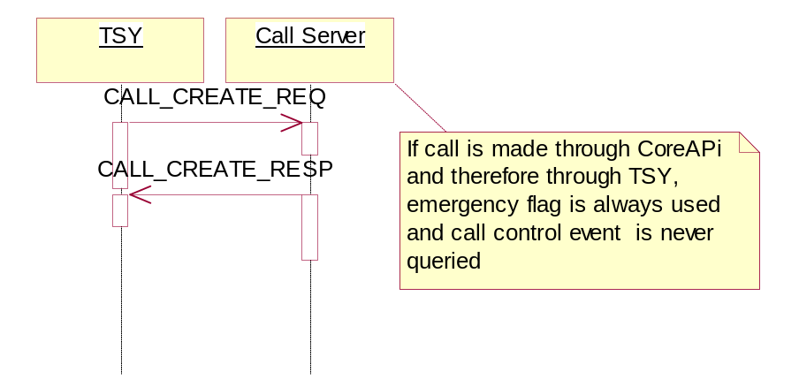
Figure 3.16: User originated emergency call via Core API
Operation | User originated emergency call via core api
Preconditions | None
Description | User originated emergency call via Core API.
Inputs | None
Modifies | None
Outputs | None
Postconditions | None
Related To | CSatCC, CTsySatMessHandler, CTsySatMessaging, CSatNotifySetUpCall
Related Event | Call control event
Exceptions | None.

User originated allowed emergency call via Commdb Api
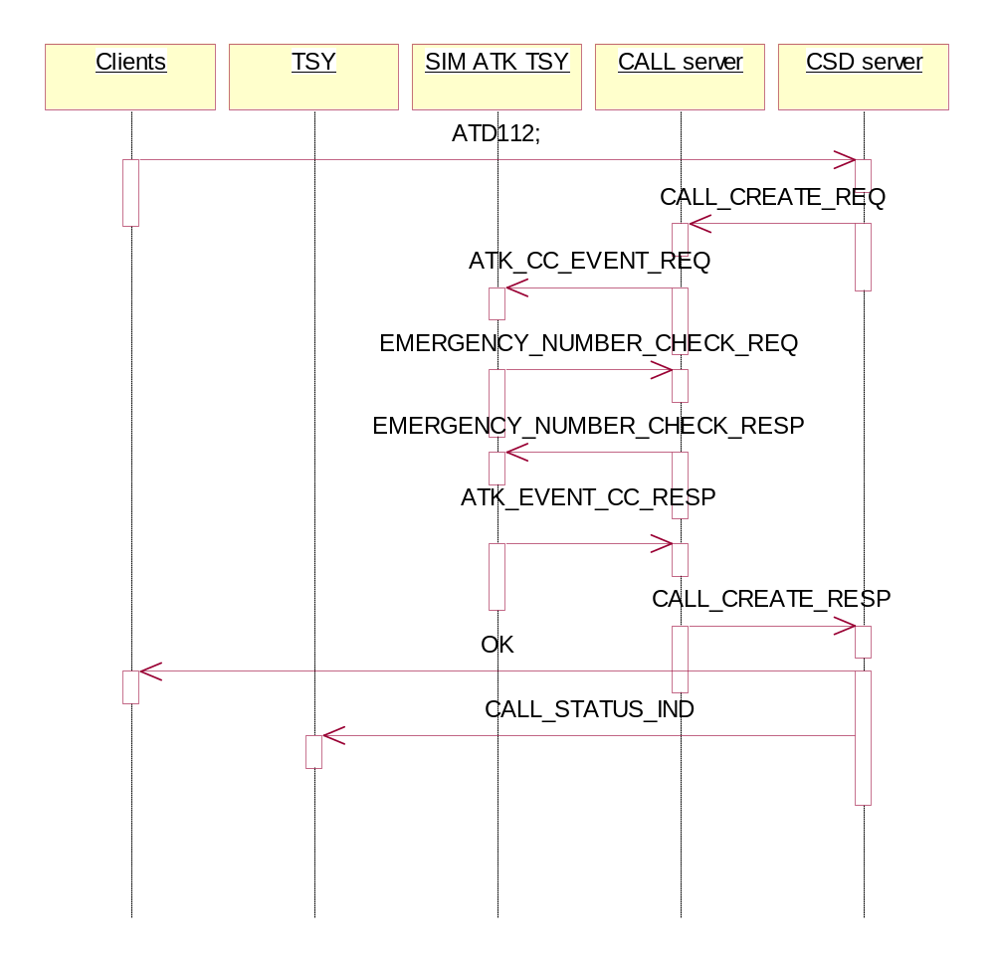
Figure 3.17: User originated allowed emergency call via Commdb Api
Operation | User originated allowed emergency call via Commdb API
Preconditions | SIM ATK TSY is running.
Description | User originated allowed emergency call via Commdb API
Inputs | Call control event request from guardian, envelope from SIMSON
Modifies | None
Outputs | Call control event response. Envelope to SIMSON
Postconditions | SIM ATK TSY is running
Related To | CSatCC, CTsySatMessHandler, CTsySatMessaging,
Related Event | Call control event
Exceptions | Message sending fails, message responsing fails.

Proactive originated emergency call
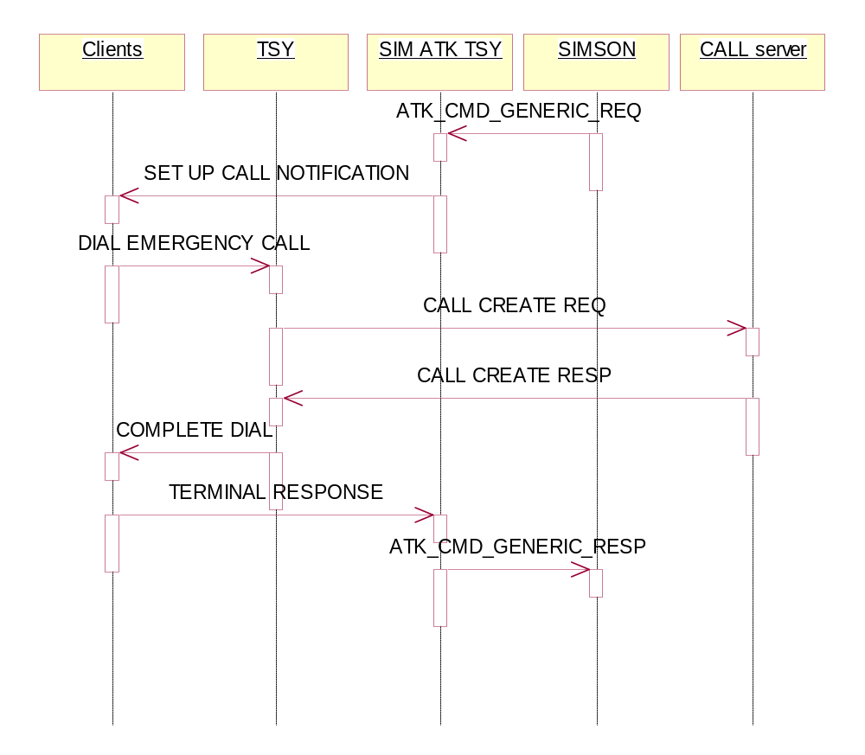

Figure 3.18: Proactive originated emergency call
Operation | Proactive originated emergency call
Preconditions | SIM ATK TSY is running.
Description | Proactive originated emergency call
Inputs | Proactive command from SIMSON
Modifies | None
Outputs | Terminal response to SIM
Postconditions | SIM ATK TSY is running
Related To | CTsySatMessHandler, CTsySatMessaging, CSatNotifySetUpCall
Related Event | Set up call
Exceptions | Message sending fails, message responding fails.

Modified Call

Basic user originated call modified to other call
Basically same thing as in chapter 3.3.2.2.1.1 what comes to sequence.

Basic proactive originated call modified to other call
Basically same thing as in chapter 3.3.2.2.1.2 what comes to sequence.

Basic user originated call modified to emergency call
Basically same thing as in chapter 1.3.11 what comes to sequence. Emergency call number check is not made in TSY before sending event response to call server. This is because number check would have to done by checking it from call server and call server makes that anyways if request comes as normal call to it. This way is considered more efficient

Basic proactive originated call modified to emergency call
Same thing as in chapter 3.3.2.2.1.3. There are some problems with retrieving the right return value from client, but that is not a fatal problem.

Basic user originated call modified to SS request
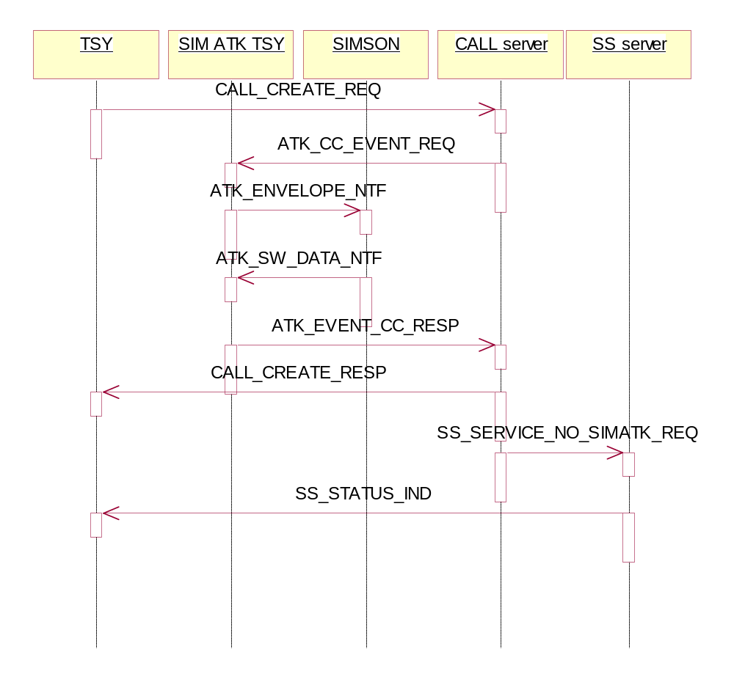
Figure 3.19: Basic user originated call modified to SS request
Operation | Basic user originated call modified to SS request
Preconditions | SIM ATK TSY is running.
Description | Basic user originated call modified to SS request
Inputs | Call control event request from guardian, envelope from SIM
Modifies | None
Outputs | Call control event response to guardian, envelope to SIM
Postconditions | SIM ATK TSY is running
Related To | CSatCC, CTsySatMessHandler, CTsySatMessaging,
Related Event | Call control event
Exceptions | Message sending fails, message responding fails.

Basic proactive originated call modified to SS request
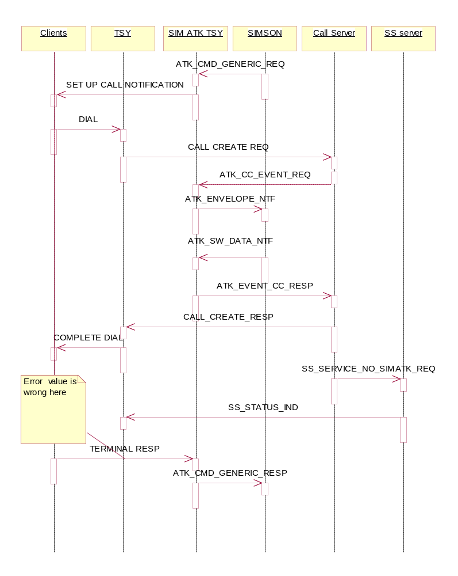
Figure 3.20: Basic user originated call modified to SS request
Operation | Basic user originated call modified to SS request
Preconditions | SIM ATK TSY is running.
Description | Basic user originated call modified to SS request
Inputs | Call control event request from guardian, envelope from SIM
Modifies | None
Outputs | Call control event response to guardian, envelope to SIM
Postconditions | SIM ATK TSY is running
Related To | CSatCC, CTsySatMessHandler, CTsySatMessaging
Related Event | Call control event
Exceptions | Message sending fails, message responding fails.

Basic user originated call modified to USSD request
Same as in 3.3.2.2.2.5

Basic proactive originated call modified to USSD request
Same as in 3.3.2.2.2.6

Rejected call

Basic user originated call
Same as in 1.3.1.1

Basic proactive originated call
Same as in 1.3.1.2

SS

Allowed SS

Basic user originated SS request
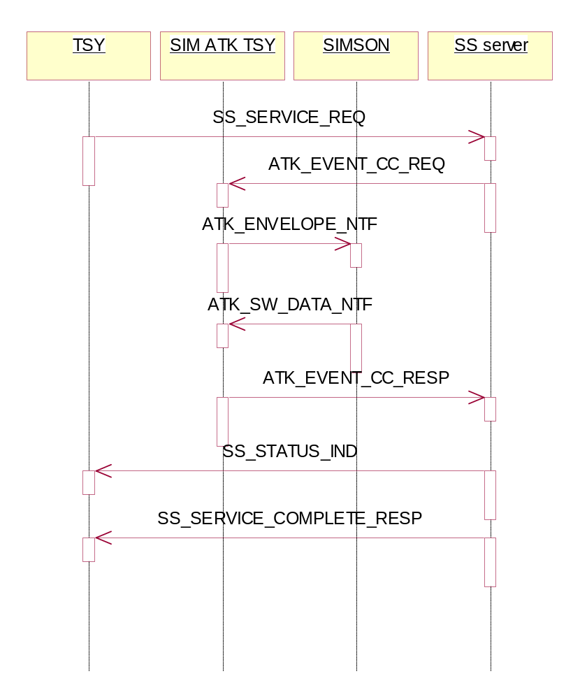
Figure 3.21: Basic user originated SS request
Operation | Basic user originated SS request
Preconditions | SIM ATK TSY is running.
Description | Basic user originated SS request from call control point of view
Inputs | Call control event request from guardian, envelope from SIMSON
Modifies | None
Outputs | Call control event response, envelope to SIMSON
Postconditions | SIM ATK TSY is running
Related To | CSatCC, CTsySatMessHandler, CTsySatMessaging,
Related Event | Call control event
Exceptions | Message sending fails, message receiving fails

Basic proactive originated SS request
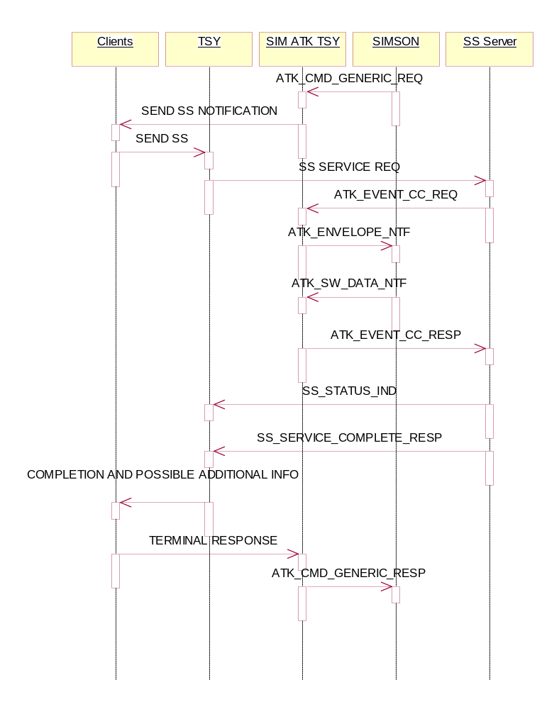
Figure 3.22: Basic Proactive originated ss request
Operation | Basic proactive originated ss request
Preconditions | SIM ATK TSY is running
Description | Basic proactive originated ss request from call control point of view
Inputs | Proactive command from SIMSON, call control event request from guardian, envelope from SIMSON
Modifies | None
Outputs | Call control event response to guardian, envelope to SIMSON, Terminal response to SIMSON
Postconditions | SIM ATK TSY is running
Related To | CSatCC, CTsySatMessHandler, CTsySatMessaging, CSatNotifySendSs
Related Event | Call control event
Exceptions | Message sending fails, message receiving fails.

Modified SS

Basic user originated SS request modified to other SS request
Same sequence as described in 3.3.2.3.1.1.

Basic proactive originated SS request modified to other SS request
Same sequence as described in 3.3.2.3.1.2

Basic user originated SS request modified to Call request

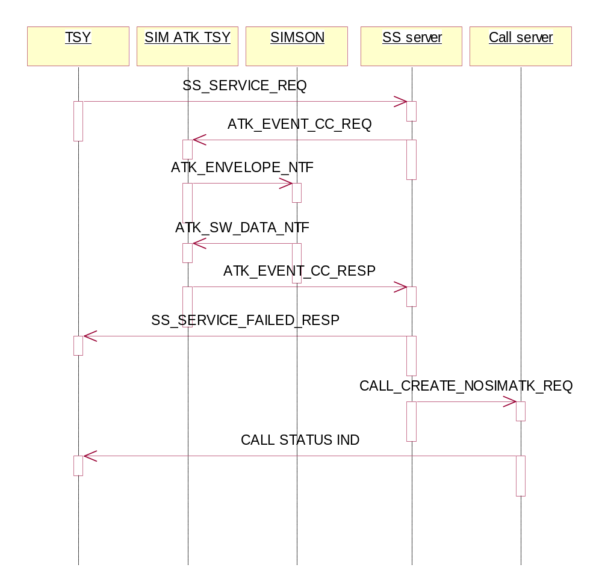

Figure 3.23 Basic user originated SS modified to Call request
Operation | Basic user originated SS modified to call request
Preconditions | SIM ATK TSY is running
Description | Basic user originated SS modified to call request
Inputs | Call control event request from guardian, envelope from SIMSON
Modifies | None
Outputs | Call control event response to guardian, envelope to SIMSON,
Postconditions | SIM ATK TSY is running
Related To | CSatCC, CTsySatMessHandler, CTsySatMessaging
Related Event | Call control event
Exceptions | Message sending fails, message receiving fails

Basic proactive originated SS request modified to Call request
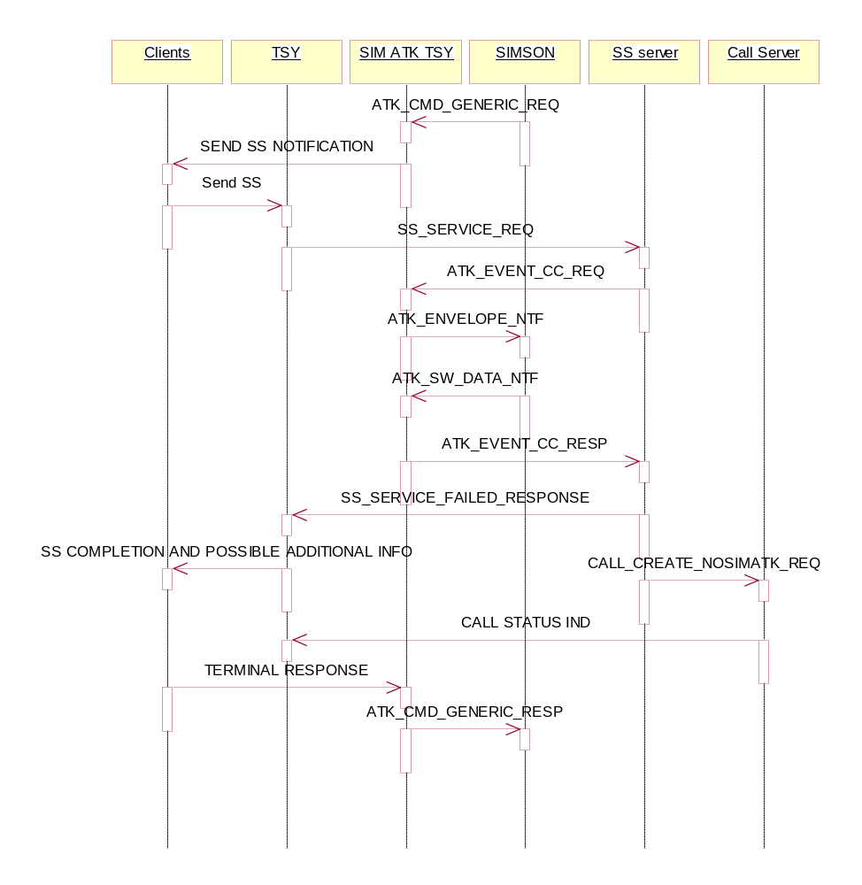
Figure 3.24 Basic proactive originated SS modified to Call request
Operation | Basic proactive originated SS request modified to call request
Preconditions | SIM ATK TSY is running
Description | Basic proactive originated SS request modified to call request from call control point of view
Inputs | Proactive command from SIMSON, call control event request from guardian, envelope from SIMSON
Modifies | None
Outputs | Call control event response to guardian, envelope to SIMSON, Terminal response to SIMSON
Postconditions | SIM ATK TSY is running
Related To | CSatCC, CTsySatMessHandler, CTsySatMessaging, CSatNotifySendSs
Related Event | Call control event
Exceptions | Message sending fails, message receiving fails

Basic user originated SS request modified to USSD request
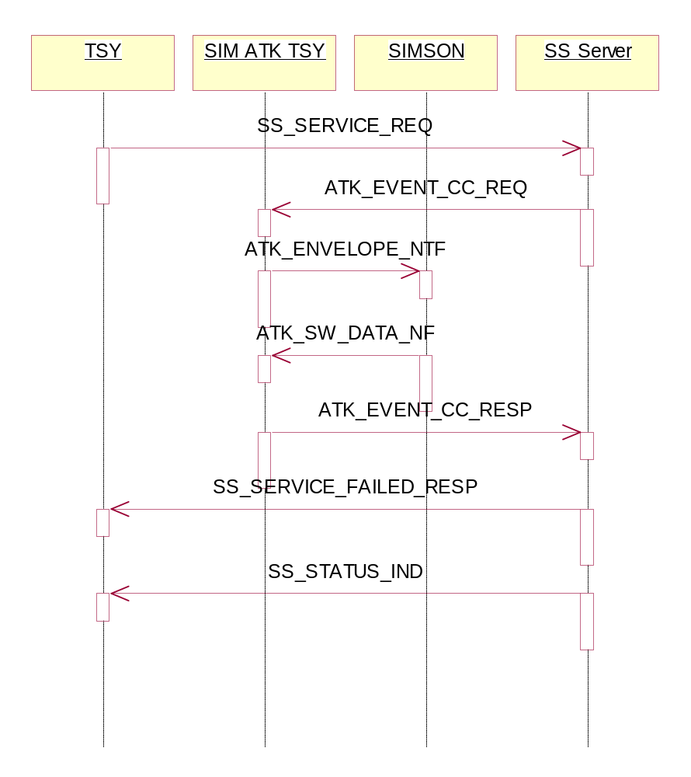
Figure 3.25 Basic user originated SS request modified to USSD request
Operation | Basic user originated SS request modified to USSD request
Preconditions | SIM ATK TSY is running
Description | Basic user originated SS request modified to USSD request
Inputs | Proactive command from SIMSON, call control event request from guardian, envelope from SIMSON
Modifies | None
Outputs | Call control event response to guardian, envelope to SIMSON, Terminal response to SIMSON
Postconditions | SIM ATK TSY is running
Related To | CSatCC, CTsySatMessHandler, CTsySatMessaging
Related Event | Call control event
Exceptions | Message sending fails, message receiving fails

Basic proactive originated SS request modified to USSD request
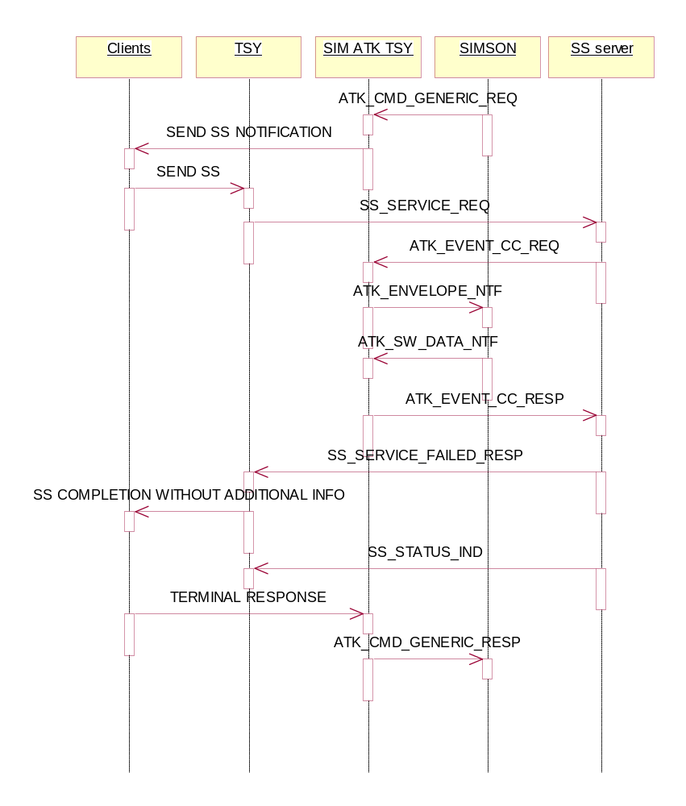
Figure 3.26 Basic proactive originated SS request modified to USSD request
Operation | Basic proactive originated SS request modified to USSD request
Preconditions | SIM ATK TSY is running
Description | Basic proactive originated SS request modified to USSD request
Inputs | Proactive command from SIMSON, call control event request from guardian, envelope from SIMSON
Modifies | None
Outputs | Call control event response to guardian, envelope to SIMSON, Terminal response to SIMSON
Postconditions | SIM ATK TSY is running
Related To | CSatCC, CTsySatMessHandler, CTsySatMessaging, CSatNotifySendSs
Related Event | Call control event
Exceptions | Message sending fails, message receiving fails

Rejected SS

Basic user originated SS request
Same sequence as in 3.3.2.3.1.1 except instead of SS_STATUS_IND SS server responds with SS_SERVICE_FAILED_RESP.

Basic proactive originated SS request
Same sequence as in 3.3.2.3.1.2 except instead of SS_STATUS_IND SS server responds with SS_SERVICE_FAILED_RESP

USSD

Allowed USSD

Basic user originated USSD request
Same sequence as in 3.3.2.3.1.1 except instead of SS_SERVICE_REQ TSY sends SS_GSM_USSD_SEND_REQ and instead of SS_STATUS_IND it gets SS_GSM_USSD_SEND_RESP

Basic proactive originated USSD request
Same sequence as in 3.3.2.3.1.2 except instead of SS_SERVICE_REQ TSY sends SS_GSM_USSD_SEND_REQ and instead of SS_STATUS_IND it gets SS_GSM_USSD_SEND_RESP

Modified USSD

Basic user originated USSD request modified to other USSD request
Same sequence as in 3.3.2.3.2.1 except instead of SS_SERVICE_REQ TSY sends SS_GSM_USSD_SEND_REQ and instead of SS_STATUS_IND it gets SS_GSM_USSD_SEND_RESP.

Basic proactive originated USSD request modified to other USSD request
Same sequence as in 3.3.2.3.2.2 except instead of SS_SERVICE_REQ TSY sends SS_GSM_USSD_SEND_REQ and instead of SS_STATUS_IND it gets SS_GSM_USSD_SEND_RESP.

Basic user originated USSD request modified to Call request
Same sequence as in 3.3.2.3.2.3 except instead of SS_SERVICE_REQ TSY sends SS_GSM_USSD_SEND_REQ and instead of SS_STATUS_IND it gets SS_GSM_USSD_SEND_RESP.

Basic proactive originated USSD request modified to Call request
Same sequence as in 3.3.2.3.2.4 except instead of SS_SERVICE_REQ TSY sends SS_GSM_USSD_SEND_REQ and instead of SS_STATUS_IND it gets SS_GSM_USSD_SEND_RESP.

Basic user originated USSD request modified to SS request
Same sequence as in 3.3.2.3.2.5 except instead of SS_SERVICE_REQ TSY sends SS_GSM_USSD_SEND_REQ and instead of SS_STATUS_IND it gets SS_GSM_USSD_SEND_RESP.

Basic proactive originated USSD request modified to SS request
Same sequence as in 3.3.2.3.2.6 except instead of SS_SERVICE_REQ TSY sends SS_GSM_USSD_SEND_REQ and instead of SS_STATUS_IND it gets SS_GSM_USSD_SEND_RESP.

Rejected USSD

Basic user originated USSD request
Same sequence as in 3.3.2.3.3.1 except instead of SS_SERVICE_REQ TSY sends SS_GSM_USSD_SEND_REQ and instead of SS_STATUS_IND it gets SS_SERVICE_FAILED_RESP.

Basic proactive originated USSD request
Same sequence as in 3.3.2.3.3.2 except instead of SS_SERVICE_REQ TSY sends SS_GSM_USSD_SEND_REQ and instead of SS_STATUS_IND it gets SS_SERVICE_FAILED_RESP.

Data Download to SIM

Startup

Activation of CB Data Download and retrieval of the list containing the allowed msg id:s.

At start up, SimAtkTsy has to retrieve the list of allowed message identifiers stored in the elementary file EFcbmid, in order to send a request to ISA SMS server to activate the reception for these kinds of messages.

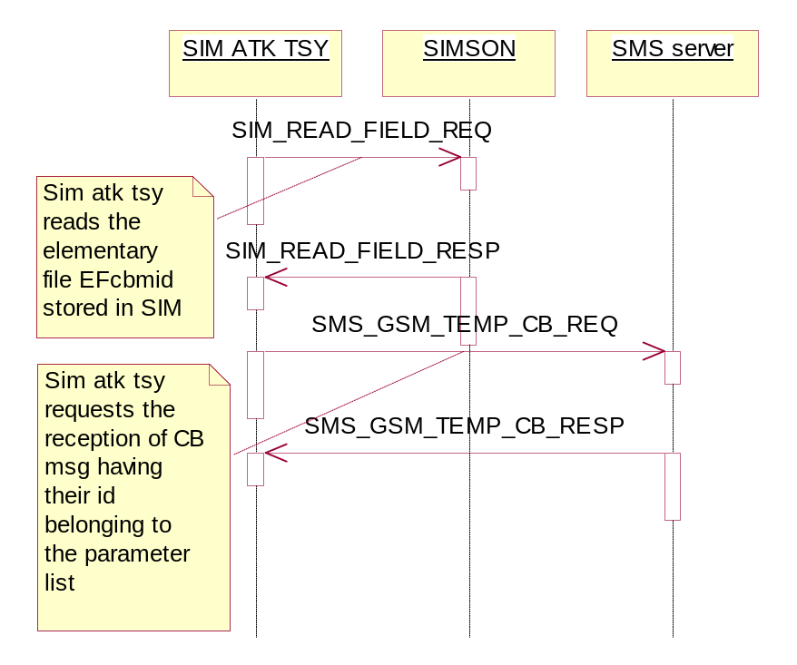
Figure 3.27 Activation of Cell Broadcast Data Download to SIM
Operation | Activation of Cell Broadcast data download to SIM
Preconditions | SIM ATK TSY is not running
Description | Activation of Cell Broadcast data download to SIM
Inputs | Sim field reading response, SMS Cell broadcast response
Modifies | List of CB DDL Msg Ids
Outputs | Sim field reading request, SMS cell broadcast request
Postconditions | SIM ATK TSY is running
Related To | CSatDataDownload, CTsySatMessHandler, CTsySatMessaging
Related Event | Start up
Exceptions | Start up fails, message sending fails, message receiving fails

Activation of SMS-PP Data Download messages
At start up, SimAtkTsy requests routing of SMS-Point to Point messages of type SMS_GSM_DELIVER_TYPE, and the service type is SMS_GSM_SIM_PP_DATA_DOWNLOAD.

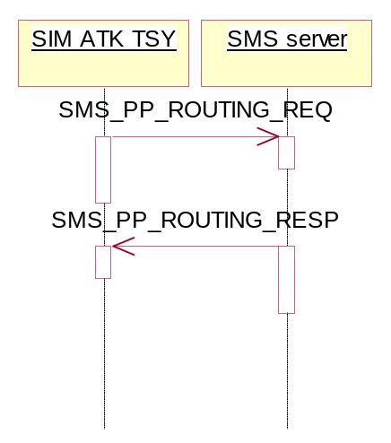
Figure 3.28 Activation of SMS-PP Data Download messages
Operation | Activation of SMS-PP data download
Preconditions | SIM ATK TSY is not running
Description | Activation of SMS-PP data download
Inputs | SMS PP routing response
Modifies | None
Outputs | SMS PP routing request
Postconditions | SIM ATK TSY is running
Related To | CSatDataDownload, CTsySatMessHandler, CTsySatMessaging
Related Event | SMS PP data download activation
Exceptions | Message sending fails, message receiving fails

Cell Broadcast Data Download reception
When SimAtkTsy receives an indication notifying the reception of CB message, it checks whether this message identifier belongs to the list of allowed message identifiers. The message is forwarded to SIMSON using Envelope format only in the positive case.
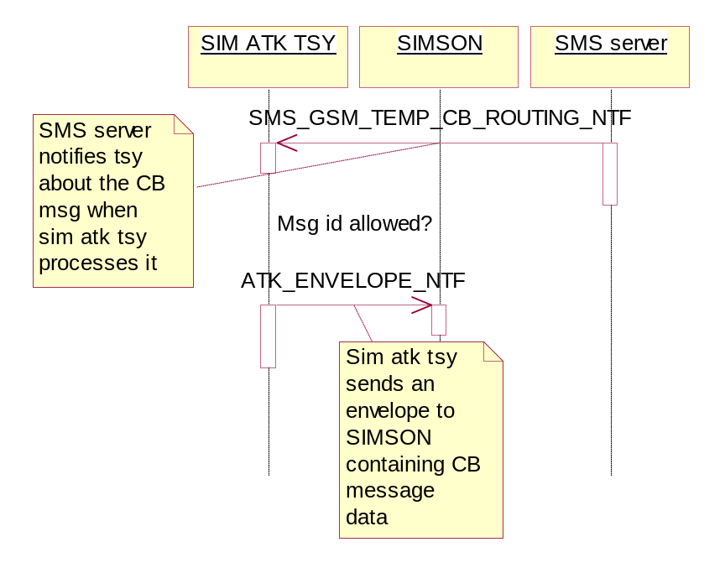

Figure 3.29 Cell Broadcast Data Download reception
Operation | Cell broadcast data download reception
Preconditions | SIM ATK TSY is running
Description | Cell broadcast data download reception
Inputs | SMS cell broadcast routing notification
Modifies | None
Outputs | Envelope to SIMSON
Postconditions | SIM ATK TSY is running
Related To | CSatDataDownload, CTsySatMessHandler, CTsySatMessaging
Related Event | Cell broadcast data download reception
Exceptions | Message sending fails, message receiving fails

SMS-PP Data Download reception

When SimAtkTsy receives an indication notifying the reception of an SMS-PP message, SIM ATK TSY sends an envelope containing the message data to SIMSON, waits for the response from SIMSON, and sends a report containing SIMSON response data to SMS server. It is at SIM card’s responsibility to carry out the actual update.
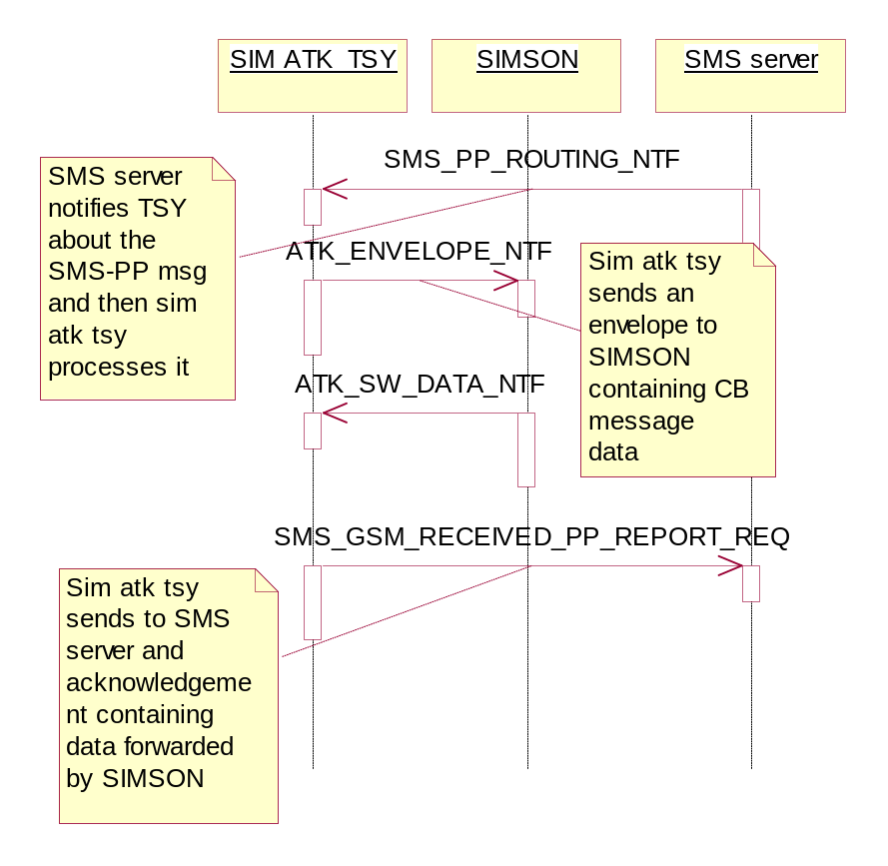
Figure 3.30 SMS-PP Data Download reception
Operation | SMS-PP data download reception
Preconditions | SIM ATK TSY is running
Description | SMS-PP data download reception
Inputs | SMS-PP routing notification, envelope receiving verification from SIMSON
Modifies | None
Outputs | Envelope to SIMSON, SMS PP receiving report request to SMS server
Postconditions | SIM ATK TSY is running
Related To | CSatDataDownload, CTsySatMessHandler, CTsySatMessaging
Related Event | SMS-PP data download reception
Exceptions | Message sending fails, message receiving fails

Refresh

Refresh can be rejected by several entities. First level is at SIM ATK TSY right away when command is received. It checks is the received refresh command in correct format. Then Satserver or its Clients can reject the case same way as SIMSON. In all of those cases terminal response is sent with general result indicating error to UICC:

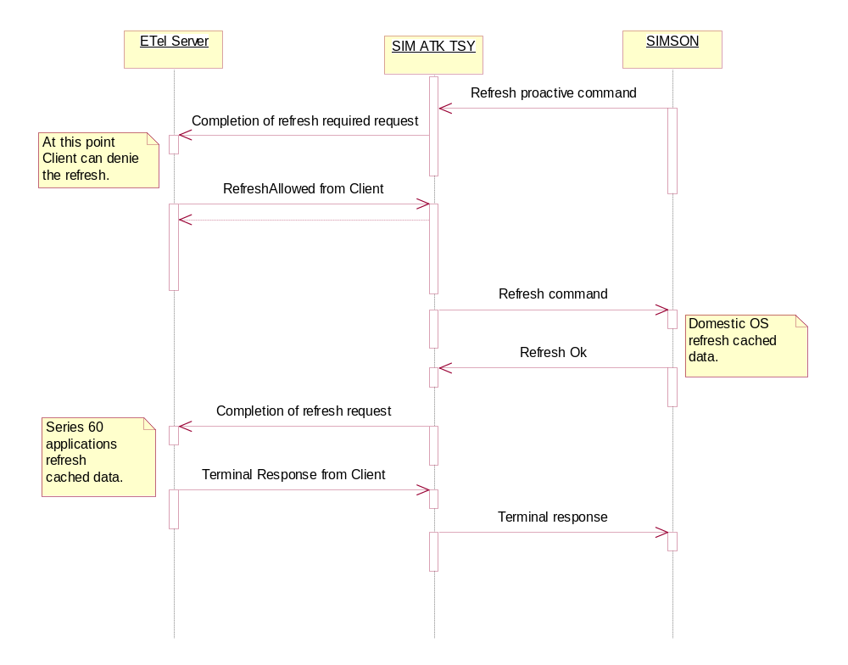
Figure 3.31 Refresh general scenario

Operation | Refresh general scenario
Preconditions | SIM ATK TSY is running
Description | Handling of refresh command in general successful situation
Inputs | Refresh proactive command, refresh request to net server , RefreshAllowed from Client.
Postconditions | SIM ATK TSY is running
Related To | CTsySatMessHandler, CTsySatMessaging, CtsySatNotifications
Related Event | Refresh
Exceptions | Client denies the refresh, refresh fails in SIMSON, message sending fails, message receiving fails,
Modifies | None
Outputs | Completion of refresh notification request, refresh response from net server

MO Short Message Control by UICC

If MO short message control is activated on the UICC, all MO short message attempts comes first to SIM ATK TSY before sending to the network. Othervies SIM ATK TSY has no task regarding to SMS sending.

Start Up

Activation of MO SMS control

At start up SIM ATK TSY has to check if MO SMS control is allocated and activated on UICC attached to mobile phone. It checks this information by checking UICC service table of the card.
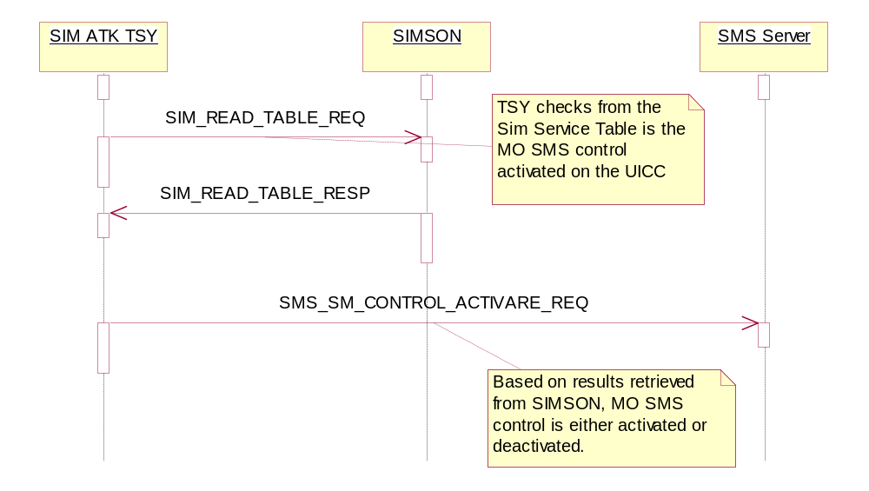
Figure 3.32 Start up from MO SMS Control point of view
Operation | Start up from MO SMS control point of view
Preconditions | SIM ATK TSY is not running.
Description | Start up from MO SMS control point of view.
Inputs | SIM ATK TSY starting request
Modifies | Gathers required information for MO SMS control, activates/deactivates guardians
Outputs | SIM service table reading request, MO SMS control activation indication
Postconditions | SIM ATK TSY is running and ready to handle MO SMS control
Related To | CSatMoSmsCtrl, CTsySatMessHandler, CTsySatMessaging
Related Event | Start up
Exceptions | Message receiving fails, message sending fails, start up fails

Allowed SMS

Basic User originated SMS
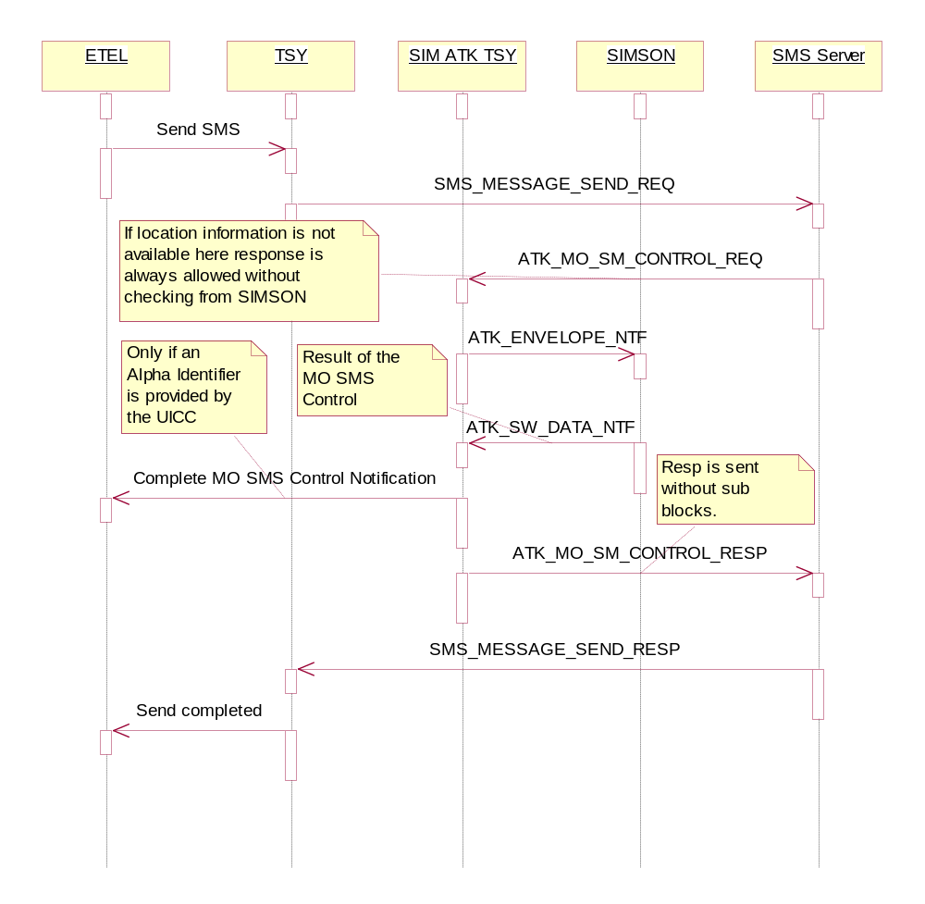
Figure 3.33 Basic user originated SMS from MO SMS control point of view.
Operation | Basic user originated SMS from MO SMS control point of view.
Preconditions | SIM ATK TSY is running.
Description | Basic user originated SMS from MO SMS control point of view.
Inputs | SMS control event request from SMS Server, envelope from SIMSON
Modifies | None
Outputs | SMS control event response, envelope to SIMSON
Postconditions | SIM ATK TSY is running
Related To | CSatMoSmsCtrl, CTsySatMessHandler, CTsySatMessaging
Related Event | SMS control event
Exceptions | Message receiving fails, message sending fails.

Basic proactive originated SMS request
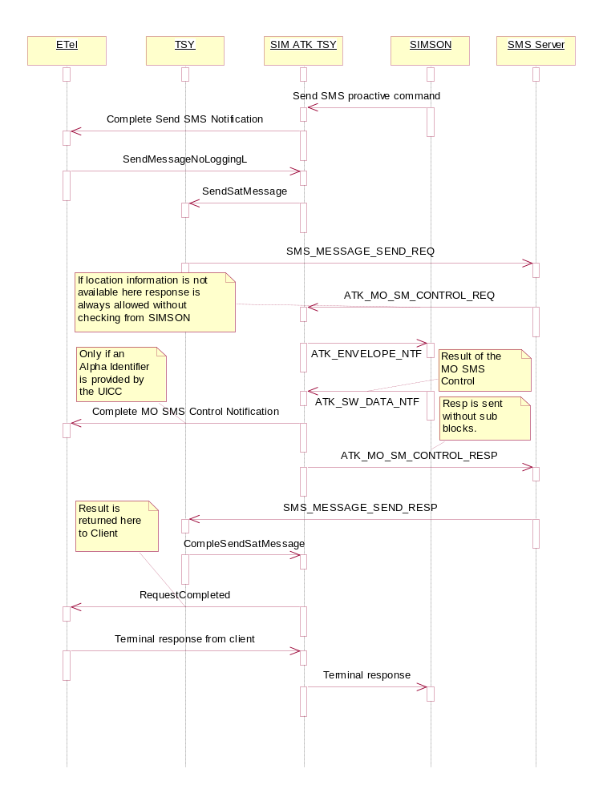
Figure 3.34 Basic proactive originated SMS request sequence diagram
Operation | Basic proactive originated SMS from MO SMS control point of view.
Preconditions | SIM ATK TSY is running.
Description | Basic proactive originated SMS from MO SMS control point of view.
Inputs | SMS control event request from SMS Server, envelope from SIMSON
Modifies | None
Outputs | SMS control event response, envelope to SIMSON
Postconditions | SIM ATK TSY is running
Related To | CSatMoSmsCtrl, CTsySatMessHandler, CTsySatMessaging
Related Event | SMS control event
Exceptions | Message receiving fails, message sending fails.

Modified SMS

Same sequence as in 3.3.5.2.1 and 3.3.5.2.2 except ATK_MO_SMS_CONTROL_RESP contains ATK_SB_SMS_ADDR sub block(s).

Rejected SMS

Same sequence as in 3.3.5.2.1 and 3.3.5.2.2.

System Resource Usage

Files
SIM ATK TSY is using file writing capabilities for test log writing purposes.

Databases
This SW does not use any databases.

Memory consumption
Memory consumption has been considered.

Task allocation
The SIM ATK TSY and ETel server run in the same thread that belongs to the communications process of the Symbian OS.

Performance
So far this has not been a problem.

Timers
There is a timer for fulfilling the needs of timer management feature. It is set on when timer management proactive command ordering activation is received. As long some time is requested to be on timer is active and running. When time runs out, timer is closed.
Every second the beat method in timer is called, this method checks if any entry in the response timer store has an old time stamp

Exception handling
Symbian OS TRAP macros are used for controlled recovery from out-of-memory situation. If the SIM ATK TSY runs out of memory the code execution leaves to the latest TRAP before the place where out-of-memory state is detected. Memory allocated after TRAP is released and request is completed to Etel server/client if possible. TRAPs are memory consuming and also quite heavy in performance. Because of this these macros are placed only to few certain central places to minimize overhead caused by them.

Limitations
Because of the different architecture SAT can only have one client, which is SAT Server.
Multiple sessions are not supported.
When phone boots up client of SIM ATK TSY has to always send notification request to all features it supports it they are set supported in terminal profile. Otherwise there is a chance that SAT functionality gets stucked in phone.
Due the boot up terminal profile is defined and given in domestic OS side.

Interfaces to Common TSY and Nokia TSY

Start-up and closing
CMmPhoneFactoryTsy of CommonTsy calls NewL-method of CTsySatMessaging class. CTsySatMessaging informs CMmPhonetReceiver class of Nokia TSY about sat message handler by calling CMmPhoNetReceiver::SetSatMessHandler. CTsySatMessaging checks proactive command buffer of CMmPhonetReceiver by calling CMmPhoNetReceiver::SatReady to check if there has came proactive commands before SIM ATK TSY has been started. In closing CMmPhoNetReceiver::SetSatMessHandler is called again.

Message receiving and sending
CMmPhoNetReceiver of Nokia Tsy calls SatMessageReceivedL method of CTsySatMessHandler class when SIM ATK related messages are received from ISCAPI. CTSySatMessHandler calls CMmPhoNetSender::Send of Nokia TSY when messages are sent to ISCAPI.

SMS sending
CTsySatMessaging calls CMmPhoneTsy::SmsSession to retrieve pointer to SMS tsy. CTsySatMessaging calls CMmSmsTsy::SendSatMessage of Common TSY when SIM ATK TSY wants to send a SMS message to ISCAPI. CMmSmsTsy calls CTsySatMessaging::CompleteSendSmsMessage of SIM ATK TSY when a response to the SIM ATK TSY originated SMS message has been received.

Status of MO SMS Control activation
CommonTSY can ask status of MO SMS control by calling CTsySatMessaging::IsMoSmControlBySimActivated method. ETrue or EFalse is returned depending on is the MO SMS control activarted or not on the UICC.

SIM ATK TSY functionality versus (U)SAT API

Supported features that behave as specified in (U)SAT API
Following features are supported by SIM ATK TSY as specified in (U)SAT API.
- Icon support
- Display text
- Get Inkey
- Get Input
- Play Tone
- Set Up Menu
- Select Item
- Send Short Message
- Send USSD
- Set Up Call
- Set Up Event list
- Set Up Idle Mode Text
- Language Notification
- Bearer Independent Protocol
- Refresh

Supported features that behave differently than specified in (U)SAT API

Call Control
This feature was handled totally in Domestic OS side in previous Nokia phones with Symbian OS. Because there was no will to change Series 60 sat server and time limit it was decided to keep this feature not using (U)SAT API as specified despite there is no longer functional reason for such behavior. Now call, ss and ussd requests are intercepted at Domestic OS side where they are sent to SIM ATK TSY for checking. Modification and rejection of the original request occurs also completely at Domestic OS side. RSat::NotifyCallControlRequest notifies clients about the change or rejection if it is required by SIM. Calling of all other call control related API functions will give KErrNotSupported error. For sequence details, see chapter 3.3.2.

Send SS
Send SS works as specified in (U)SAT API. Only difference is that part of the return value reporting of ss sending attempt is delivered to Client through Custom API.

Provide local info
Provide local info is mostly invisible to (U)SAT API. ESN is not supported. Only language information is queried from client side by using (U)SAT API.

MO Short Message control by UICC
This feature is mainly handled in SIM ATK TSY. All MO SMS control requests comes directly from Domestic OS. (U)SAT API is used only for displaying a possible alpha ID provided by the UICC.

Event download
MT Call, Call Connected, Call Disconnected, Location Status and Access Technology Change events are purely handled in SIM ATK TSY and (U)SAT API is not used for these events. SIM ATK TSY uses different ISI-indications to gather required information for these events.
User Activity, Idle Screen Availeable, Browser Termination, Language Selection, Data Available and Channel Status Events work as specified in (U)SAT API.

Supported features that are not visible to (U)SAT API
SIM ATK TSY supports following features but clients will receive KErrNotSupported error code by trying to use them.

Terminal profile
Start up order of Nokia phones with Symbian OS is such that terminal profile of the phone cannot be given by client of (U)SAT API as specified in (U)SAT API specification SIM ATK TSY is started up by Satserver client and there is no way it could be started fast enough to give profile in time specified by ETSI GSM Specification 11.14 document. Therefore terminal profile is handled totally inside Domestic OS. If client tries to send terminal profile by using RSat::ClientSatProfileIndication method they will get error code KErrNotSupported. This issue should be considered by Domestic OS integrators.

Cell Broadcast Data download
This feature was handled totally in Domestic OS side in previous Nokia phones with Symbian OS. Because there was no will to change Series 60 sat server and time limit it was decided to keep this feature not using (U)SAT API despite there is no longer functional reason for such behaviour. If clients try to get information about cell broadcast data download by using RSat::NotifyCBDownload method they will get error code KErrNotSupported.

SMS-PP Data download
This feature was handled totally in Domestic OS side in previous Nokia phones with Symbian OS. Because there was no will to change Series 60 sat server and time limit it was decided to keep this feature not using (U)SAT API despite there is no longer functional reason for such behavior. If clients try to get information about SMS-PP data download by using RSat::NotifySmsPpDownload method they will get error code KErrNotSupported.

Timer management
This feature was handled totally in Domestic OS side in previous Nokia phones with Symbian OS. Because there was no will to change Series 60 sat server and time limit it was decided to keep this feature not using (U)SAT API despite there is no longer functional reason for such behavior. If clients try to get information about timer management download by using RSat::NotifyTimerMgmtPCmd method they will get error code KErrNotSupported.

More time
There is no support for this in (U)SAT API. However SIM ATK TSY supports this feature.

Event Download
This feature was handled totally in Domestic OS side in previous Nokia phones with Symbian OS. Because there was no will to change Series 60 sat server and time limit it was decided to keep part of the event handling below API despite there is no longer functional reason for such behavior. If clients try to get information about requested event list by using RSat::NotifySetUpEventListPCmd method they will get list where events handled by SIM ATK TSY are stripped away. These events are mentioned in chapter 8.2.5.

Polling Off
This feature was handled totally in Domestic OS side in previous Nokia phones with Symbian OS. Because there was no will to change Series 60 sat server and time limit it was decided to keep this feature not using (U)SAT API despite there is no longer functional reason for such behavior. If clients try to get information about polling off by using RSat:: RSat::NotifyPollingOffPCmd method they will get error code KErrNotSupported.

Poll Interval
This feature was handled totally in Domestic OS side in previous Nokia phones with Symbian OS. Because there was no will to change Series 60 sat server and time limit it was decided to keep this feature not using (U)SAT API despite there is no longer functional reason for such behavior. If clients try to get information about poll interval by using RSat::NotifyPollingIntervalPCmd method they will get error code KErrNotSupported.

Not supported features by SIM ATK TSY but defined by (U)SAT API.
SIM ATK TSY does not support following features and clients will receive KErrNotSupported error code by trying to use them.

- Perform Card APDU
- Power Off Card
- Power On Card
- Get Reader Status PCmd
- Run AT Command
- Service Reach
- Get Service Info
- Declare Service
- Notify Proactive SIM Session Start
- Notify TSY Cache Updated
- USat Client Ready Indication
- Terminal Response Cancel.
- Card Reader Status event
- Display Params Changes event
- Local Connection event
- Provisioning File handling for Launch browser command

Other deviations
Series 60 Satserver does not check much error codes that SIM ATK TSY is sending to it. Basically it understands only situations where request was successful ( KErrNone ), request was unsupported ( KErrNotSupported, no reattempt ) and request was unsuccessful ( all other possible error codes, when it just posts the request again in case of notify requests or totally ignores the return value as in case of terminal response sending requests ). Because of this although SIM ATK TSY is checking the correctness of parameters of terminal response and returning error value KErrCorrupt if the input parameters are found faulty it still passes the terminal response to Domestic OS. Also notifications for all proactive commands are not completed to client. Instead terminal response is sent to SIMSON as soon as SIM ATK TSY has completed requested action or gathered the requested data.
Proactive originated call, ss and ussd requests are checked against the FDN. This is because commontsy and nokiatsy are not currently supporting call, ss and ussd requests that would not be checked against fdn list.

